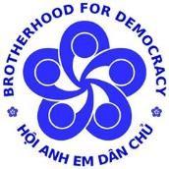
HỘI ANH EM DÂN CHỦ
BROTHERHOOD FOR DEMOCRACY

HUMAN RIGHTS REPORT VIETNAM

2021

HUMAN RIGHTS INFORMATION CENTER information.humanrights@protonmail.com Table of contents

Introduction 3
1. Freedom of speech and freedom of the press 6
a. New regulations tighten freedom of speech in Vietnam 6
b. Arrests and trials targeting professional writers and journalists 7
c. Criminalizing personal dissent 10
2. The rights to liberty and security 13
a. Several cases of suppression of activists and dissidents 14
b. Status of some other prisoners of conscience 20
c. Revenge against police officer who denounced corruption 22
d. Violence and unusual deaths 24
3. The right to participate in political life 28
a. Independent National Assembly candidates are systematically suppressed 30
b. Citizens are forced to exercise their right to vote 33
4. The rights of children 34
5. Socio-economic rights 39
a. The right to work and the right to an adequate standard of living 39
b. Strikes and union rights 40
c. Ensuring human rights principles in EVFTA 43
6. Anti-pandemic policy and human rights 46
a. The government issued a series of unconstitutional policies 46
b. Local government abuse of power 50
c. The great evacuation in peacetime 53
Conclusion 59
Appendix 62
Table 1. Arrests in 2020 (ordered by date of arrest) 62
Table 2. Trials in 2021 (ordered by date of arrest) 64

Introduction

The human rights situation in Vietnam has received a great deal of attention over the last year, from a variety of perspectives and from a variety of stakeholders.
At the intergovernmental level, the Vietnamese government has proudly mentioned their effective anti-epidemic achievements in 2020 at many international forums as solid evidence of the respect and guarantee of human rights in Vietnam. This confidence is clearly expressed in the Deputy Prime Minister and Foreign Minister Pham Binh Minh's statement on February 22, 2021, regarding Vietnam's anticipation of the Human Rights Council candidacy. To continue to demonstrate goodwill in international human rights dialogues, Vietnam actively drafted a voluntary mid-term report under the UPR cycle for the first time, informing on the progress of implementing the 241/291 recommendations that the country accepted during the 3rd UPR dialogue session in 2019.
Domestically, the year 2021 witnessed a number of significant socio-political events, including the 13th Congress of the Communist Party of Vietnam, the election of the 15th National Assembly and People's Councils at all levels, and the appointment of senior personnel in the new government term. Furthermore, the fourth nationwide Covid outbreak and the prolonged blockade have revealed delays and incompetence at all levels of government, causing frustration and deep social division. Human rights are discussed "extraordinarily" frequently throughout the year by a wide range of stakeholders, including the government, social organizations, experts and the general public. Discussions about human rights and human rights violations take place all over social networks, ranging from socio-economic and cultural rights to topics that are often more sensitive like civil - political rights.
Human rights education was initially incorporated into Vietnamese school curricula. Through Decision No. 1309/QD-TTg dated September 5, 2017, the Vietnamese government approved the Scheme to include human rights content in educational curricula in the national education system. By December 2021, this project would have been supplemented by Directive No. 34/CT-TTg on strengthening the above-mentioned project's implementation. The Ho Chi Minh National Academy of Politics, also known as the Party School, is in charge of this project, and it is coordinated by a number of ministries and agencies, including the Ministry of Foreign Affairs (MOFA), the Ministry of Education, the Ministry of Labor, Invalids, and Social Affairs (MOLISA), and the Ministry of Information and Communications (MIC).
Unfortunately, contrary to the government's rhetoric, 2021 continues to be a terrible year with numerous serious human rights violations in Vietnam. The government has increased repression of dissenters, tightened freedom of speech and press, and arbitrarily distorted the rule of law to control society in order to achieve political purposes. Human rights issues have gradually gained public attention, though public awareness of violations has not improved significantly.
Vietnamese authorities have made at least 44 new arrests and put 47 dissidents on trial for different crimes in 2021. Among the crimes used to prosecute dissidents, article 331 on abuse of democratic freedoms and article 117 on propaganda against the state have been used at the highest frequency. Most of the government's accusations against these dissidents are based on dissenting but peaceful statements posted on social media.

5

13

2

1

1

1

20

1

0

5

10

15

20

25

Đ. 109

Đ. 117

Đ. 200

Đ. 276 (BLHS 1999)*

Đ. 288

Đ. 330

Đ. 331

Đ. 373

Number of new arrestees under the provisions of the 2015 Penal Code
(* Please refer to the section on Status of Prisoners of Conscience for the case of Huynh Thuc Vy)

Epidemic prevention policies are the focus of discussion in 2021, ranging from cases of forced isolation and testing to policies that are unconstitutional, inhumane and human rights violating.
In this context, the report attempts to document notable events and outline the human rights situation for 2021 as honestly as possible. The information in the report is collected from direct and indirect sources such as domestic and international press, family and individuals who have been subjected to human rights violations.

1. Freedom of speech and freedom of the press

a. New regulations tighten freedom of speech in Vietnam
The state controls strictly and completely all means of mass communication from printed publications, radio, television to online newspapers. Publications must all be under the names of newsrooms and state agencies and are subject to strict censorship from the Propaganda Department, the mouthpiece of the Communist Party of Vietnam, in order to ensure content, topics and information of the publications consistent with the Party's views. This censorship has increased even more strongly after Decision No. 362/QD-TTg on Planning and Development of Press Management to 2025 signed by the Prime Minister in 2019, according to which the number of publications is considered
“newspaper” decline and newspapers must have a direct provincial or ministerial level management agency. The above regulation applies to both printed and electronic newspapers, therefore, publications that do not meet the standards will be downgraded to journals.
In addition, a new document that took effect on February 15, 2021 is Circular No. 41/2020/TT-BTTTT of the Ministry of Information and Communications regulating the issuance of press operation licenses, which includes the establishment of newspapers, magazines and publication of publications. Accordingly, all press activities must be licensed by the Ministry of Information and Communications (MIC), and in the application for a license, agencies and organizations must present not only their project plan, list of expected personnel, but also the personnel's background, including their level of political theory and whether they are party members or not. This is a way to precensor and prevent diversity and independence of press activities.
Social networks have become the only space left for freedom of expression and information. However, this space is gradually being suffocated by various forms. On June 17, 2021, the MIC issued Decision No. 874/BTTT on the Code of Conduct on Social Media with applicable subjects including organizations and individuals using social networks. Article 4 of the Code requires all social media users to share information "from an official and reliable source", "not to post content that violates the law, information that insults honor, dignity and affects the legitimate rights and interests of other organizations and individuals…, causes irritation in public opinion and affects social order and safety". Just like the general, vague provisions in the Criminal Code and the Cybersecurity Law, The Code of Conduct on Social Media completely lacks definitions of official, reliable sources or indicators of behavior that damages the legitimate rights and interests of others, and acts that cause outrage in public opinion and affect social order and safety.
Vietnam has no specific documents that provide clear cut between human freedoms and legal violations, while international standards have never been quoted in legal practice in Vietnam, meaning that any legal interpretation or ideological assessment conclusions for statements and articles of individuals or organizations are based entirely on the subjective will and vague arguments of state agencies.
In addition to legal or administrative regulations, the Vietnamese government has also increased its control over the Internet and suppressed dissent in cyberspace with its official combat force. Force 47 under the Ministry of National Defense, was established in 2017 and is well-trained in "cyber combat" skills such as exploiting virtual computers via smartphones, tablet; registering accounts, reporting violated posts on Facebook; establishing a "secret group" to exchange and unify information; writing news articles. According to information collected from the websites of military command boards in some localities and provincial press agencies, each province has their Force 47 division which operates on dozens of different groups and forums and owns thousands of personal Facebook accounts; this force is constantly expanding and is now established at district level. Force 47's activities include propaganda in support of state views and suppression of dissent. This force often increases its activity on orders when there are important political events, or when it is necessary to target specific activists.
All of these press and Internet controls are part of the Vietnamese government's long-term strategy to eradicate free speech, as evidenced by arrests and long-term imprisonment for political dissidents, activists, journalists and corruption whistleblowers in general.

b. Arrests and trials targeting professional writers and journalists
Many journalists and whistleblowers have been arrested and tried during the past year. On January 5, 2021, three journalists from the Independent Journalists Association of Vietnam (IJAVN) were tried for the crime of propaganda against the State (article 117 of the 2015 Penal Code) and sentenced respectively to 15 years in prison for Pham Chi Dung, Chairman of the Association; 11 years in prison for Nguyen Tuong Thuy and Le Huu Minh Tuan. The three journalists were accused of writing, posting and sharing articles with propaganda content, distorting, defaming the people's administration, fabricating, and infringing on the reputation of the Communist Party of Vietnam in order to oppose the Socialist Republic of Vietnam.
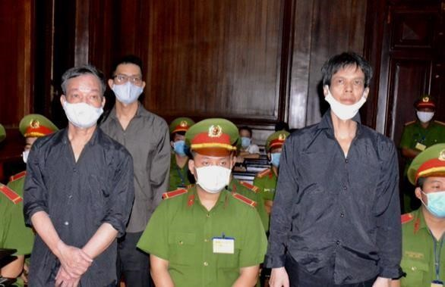
3 members of IJAVN at their first instance trial (Source: TTBC – Tuoi Tre Online)

In April 2021, another group of independent journalists, Bao sạch (Clean Newspapers), were arrested and prosecuted. The Clean Newspaper Group was established in 2019 and resonated with a series of investigative articles about the "dirty" toll collection at BOT stations, the lack of transparency and the misconduct of the investigative agency in the Ho Duy Hai case, etc. The core members of Clean Newspaper were arrested in late 2020 and early 2021, and tried on October 26, 2021. According to the indictment, the Clean News group used personal accounts, groups and fanpages on Facebook to post articles and clips, to create a forum for many people to deliver subjective, negative comments and anti-content destroying, distorting and affecting the legitimate rights and interests of leaders, the Party other organizations and individuals. Particularly, journalist Truong Chau Huu Danh, head of the Clean Newspaper group, was accused of propagating psychological warfare, bringing reactionary ideas, harming the great national unity bloc, and defaming the People's Government. These five journalists were found guilty of abusing democratic freedoms and infringing upon the legitimate rights and interests of individuals and organizations under article 331 of the Penal Code 2015 and were sentenced from 2 to 4 years and 6 months in prison.
On April 3, 2021, another professional journalist was arrested on charges of abusing democratic freedom. Nguyen Hoai Nam was arrested after making allegations of misconduct by senior investigative officials from the Ministry of Public Security. Tran Hoai Nam attracted public attention in 2018 with a series of articles exposing corruption at the Vietnam Inland Waterway Administration. Three of the officials Mr. Nam mentioned in the report were tried for abuse of position and power. Mr. Nam then accused the investigative agency of receiving "bribes" to "falsify case files" and deliberately "leave criminals out".
On July 9, the Hanoi Court sentenced dissident writer Pham Chi Thanh to 5 years and 6 months in prison according to article 117.Pham Chi Thanh (commonly known as Pham Thanh) is the owner of the blog Mrs. Dam Xoe. He is also the author of several books criticizing the regime and General Secretary Nguyen Phu Trong. He was detained by the Hanoi Security Service on May 21, 2020, on the eve of the 13th Congress of the Communist Party.

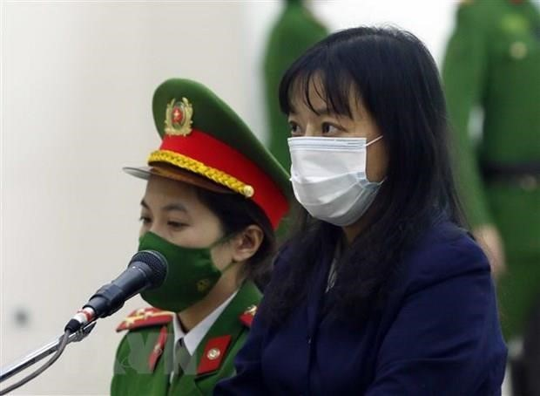
On December 14, the Court of Hanoi tried independent journalist Pham Doan Trang for allegedly conducting propaganda against the state under article 88 of the 1999 Penal Code. She was accused of having received interviews on BBC News
Vietnamese and RFA Radio Free
Pham Doan Trang at the first instance session
Asia, archiving Vietnam's human
(Source: People's Army Newspaper) rights reports which according to
the Procuracy "propagating psychological war rhetoric, spreading fabricated news to cause confusion among the public, propagating information that distorts the direction and policies of the Socialist Republic of Vietnam". This case has attracted great attention from the international community. The United Nations human rights agencies had previously concluded that the Vietnamese government had violated international human rights commitments in the arrest and trial of Pham Doan Trang. Trang was arbitrarily detained and should be released immediately and unconditionally.

c. Criminalizing personal dissent
In 2021 alone, at least 18 individuals who are simply bloggers have been criminally prosecuted and sentenced to many years in prison for writing or sharing articles expressing disagreement with the government or an official on social networks. Some notable cases include:
On March 22, 2021, the police of Nghe An province arrested Doctor Nguyen Duy Huong for infringing on national security and conducting propaganda against the state (article 117). Doctor Nguyen Duy Huong is accused of using Facebook to express his own political views and criticize state leaders after posting a "letter from the heart" to General Secretary Nguyen Phu Trong online.
On June 9, the Quang Ngai Provincial Court opened a trial for Cao Van Dung on the charge of "conducting propaganda against the state" and sentenced him to 9 years in prison and 3 years of probation. Dung was also accused of being a member of a closed group named "Brotherhood of democratic lovers and human rights for the Vietnamese people", participated in demonstrations against the Law on Cybersecurity and the USNorth Korea Summit, and posted many articles against the Party and State on social networks.
Also in June, authorities arrested 3 people in Quang Ngai and tried one person on charges of conducting propaganda against the state. The reason for accusing these 4 people is because they had shared posts that contradict the government's views regarding

the attack on Dong Tam 2019. Dang Hoang Minh, who was on trial on June 2/ 2021, was sentenced to 7 years in prison and 2 years of probation.

On July 20, Nguyen Van Lam was sentenced to 9 years in prison by the Nghe An Provincial Court for conducting propaganda against the State under article 117 of the Penal Code 2015. State media reported that from 2017 to 2020, Lam has "propagandized and incited the people against the State, against the Communist Party of Vietnam and slandered the regime and leaders" through posting articles and livestreaming on personal pages.
On August 10, Tran Hoang Huan was arrested by the Tien Giang Provincial Police on charges of violating Article 117 after a series of posts on his personal Facebook called on local authorities to strictly comply with the law and provide support to people affected by Covid pandemic.
On October 6, facebooker Vo Hoang Tho was arrested by the police of Can Tho province on charges of resisting the government when using his personal facebook to comment on anti-Covid-19 policies.
Among the above cases, the information about the trial of Le Thi Binh on April 22, 2021 posted on a website specializing in law is remarkable. The article about this trial has a passage as follows:
[...According to the indictment, Binh joined the social network Facebook with the account named “Binh Le”, then changed the name to “Le Ngoclan Ct”,
“Ngoc Lan CT Ngoc CT Le”, “Anna Nguyen”.
From October 2019 to November 2020, Binh regularly used these Facebook accounts on mobile phones with Internet connection to live stream, post and share articles with the purpose of expressing personal views for everyone to comment and share …]
The above excerpt illustrates one point of view: Binh’s illegal act is publicizing her personal views with the peaceful purpose of letting the community “comment” and

“share (their views)”. It is not clear whether the above sentence is a quote from the indictment of the Procuracy, or a statement made by the author of the article after the trial. Regardless of which side this view comes from, it represents a tremendous setback in the perception of freedom of expression. It seems that irrespective of the content,

expressing or sharing opposing views is enough to constitute a criminal offence. It is also worrisome that this misperception is posted on a major legal news site where a deep understanding and analysis of legal regulations should have been provided.
The above misconception is also reflected in civil issues, as evidenced by the firing of a female lecturer at Duy Tan University in early August. The reason given by the leader of this private university was that she "made one-sided and misleading statements about the pandemic prevention in Vietnam". The female lecturer had expressed her displeasure with state policy while arguing with a student at breaktime. The conversation was recorded by a student and posted online. The cyber-security agency later stated that they had received information and was investigating the female lecturer's statement.

2. The rights to liberty and security
Vietnam is a party to the Convention against Torture and Other Cruel, Inhuman or Degrading Treatment or Punishment. The obligation of a state party is not only to codify regulations, but also to take other proactive measures to ensure that no one is placed in a situation where they may be subjected to torture or other ill-treatment. Victims of torture must be able to denounce and appeal to an independent, impartial judicial authority and receive reasonable compensation.
Vietnamese law generally recognizes the right to liberty, security of a person in the Constitution, the Penal Code, and other laws. These regulations, however, are easily broken at the will of the authorities in various forms to suppress human rights activists,

dissidents or suppress any incident that may have negative influence on the ruling elite’s interests.
Before being arrested or prosecuted, all dissidents were subjected to threatening actions from the government, such as being attacked by trolls on the Internet, being summoned to police multiple times, being monitored, or experiencing difficulties with administrative procedures. Many activists reported being refused by the police to issue

new citizen IDs and passports when their old identification papers expired. Others are harassed by local authorities for administrative reasons, such as regularly checking business papers and constructing permits, which jeopardize their livelihoods and lives.
One of the most serious infringing measures on the right to liberty and security is the provision preventing a person accused of infringing upon national security to meet his relatives or lawyer during the investigation process in order to ensure confidentiality. The time limit for investigating a case involving national security is 4 months, and according to the provisions of the Criminal Procedure Code, the investigation time can be extended up to 4 times. The duration that a political prisoner can be held in pre-trial detention is up to 20 months. This is a form of solitary confinement designed to put detainess under psychological and physical stress.
In the second half of December alone, seven democracy-human rights activists were brought to trial in five different trials. As with other courts, these trials are rife with violations of due process and legal principles. Family members of the defendants are prevented from attending court sessions, even though the trials are theoretically open to the public. Lawyers are often made difficult to access case files and evidence. Because all judges must be members of the Party, they lack independence. They do not even maintain neutrality during the trial, frequently interrupting the accused and the lawyer.
The pandemic and prevention regulations have aggravated the plight of those who are being deprived of their liberty. Inmates have not been able to see their loved ones during the past year, many prisons have arbitrarily issued regulations that do not allow relatives to send food, medicines or other material supplies to people in custody or temporary detention. The only supply form accepted is money. Inmates are entitled to monthly calls home, but phone calls are always censored and transmissions can be cut off at any time if they bring up negative issues in the prison.
According to aggregated information from the press, many provinces and cities in Vietnam have implemented Covid vaccines for prisoners and detainees since the beginning of November. The families of some prisoners of conscience have confirmed that these prisoners were vaccinated, however, there is no information regarding the type of vaccine used or whether the prisoners had the right to refuse vaccination.

a. Several cases of suppression of activists and dissidents
In March, the Court of Hanoi opened an appellate hearing to try 6 unjust
citizens of Dong Tam on charges of murder and resisting law enforcement officers. After 2 days of trial, at 6 pm on March 9, the High Court of Hanoi affirmed the first-instance judgment with all 6 defendants. Thus, the attack on Dong Tam on the night of January 9, 2020 has claimed 4 lives and will continue to take the lives of 2 more people. Meanwhile, the authority has yet issued a death certificate for Le Dinh Kinh, the only citizen killed by the police that night.
Other petitioners from Duong Noi village including Nguyen Thi Tam, Can Thi Theu and her two sons Trinh Ba Phuong and Trinh Ba Tu were arrested in 2020 and brought to trial in 2 different trials in 2021. They are the people who fight for their land rights after the government's unfair land acquisition decision in 2010, and these 4 people also reported and strongly condemned the attack on Dong Tam in 2020. Can Thi Theu and her second son, Trinh Ba Tu, were tried on appeal on December 24, 2021 with a sentence of 8 years in prison and 3 years of probation for each. At that time, Trinh Ba Phuong and Nguyen Thi Tam were tried in another court on December 15, 2021. Trinh Ba Phuong was sentenced to 10 years in prison and 5 years of probation, Nguyen Thi Tam was sentenced to 6 years in prison and 3 years of probation.
Can Thi Theu's family is known not only for being strong fighters for land rights, but also regularly participating in peaceful protests against anti-China, supporting democracy, environmental rights and human rights in general. During the Dong Tam incident in 2020, Trinh Ba Phuong was one of the first to arrive at the scene and continuously reported on the government's attack on the villager. He also participated in drafting the Dong Tam Report with independent journalist Pham Doan Trang, which is one of the efforts to make information about the aforementioned persecution more transparent.
Because of her unyielding struggle efforts, Can Thi Theu's family suffered many human rights violations and harsh treatment from the authorities, especially during arrest and preparation for trial. The Hanoi police put Trinh Ba Phuong in a mental hospital in early March 2021 without notifying relatives. In an exchange between Trinh Ba Phuong's family and the investigator, the police revealed that they transferred Phuong to the Central Psychiatric Hospital 1 because Trinh Ba Phuong "opposed and refused to cooperate in answering questions" from the investigator. Theu and her second son Trinh Ba Tu were tried at first instance on May 5, 2021, and during the appeal process, they continued to be held in solitary confinement at the Hoa Binh Provincial Police’s Detention Center. When the lawyer went to the detention center to complain about solitary confinement on July 8, 2021, he received an answer that was due to a request from the Judgment Enforcement Department. In October, Trinh Ba Tu told his lawyer during a meeting that he was beaten so severely that his kidneys swelled and had to be hospitalized for treatment at the time he was arrested. After being sent back to the detention center to continue the investigation, Tu was humiliated and coaxed to confess in exchange for a lighter sentence.
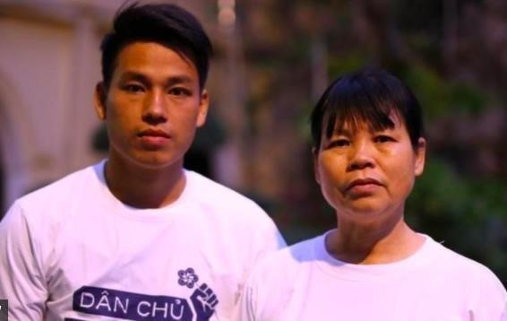
Mrs. Can Thi Theu and her son Trinh Ba Tu (source: HRW)

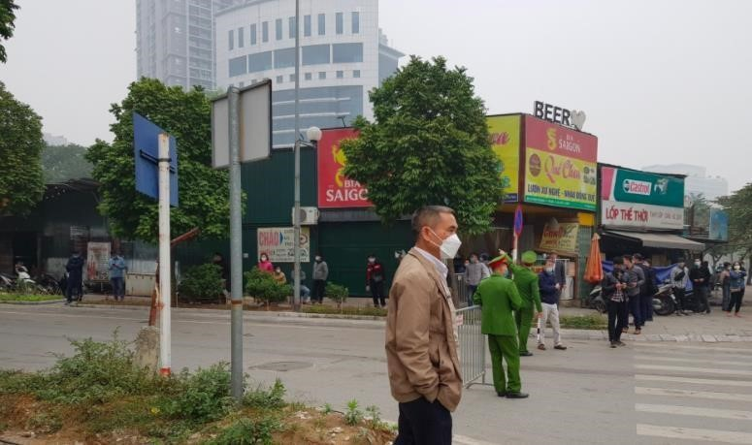
The police force is dense, blocking the entrance to the court during the trial Trinh Ba Tu and Nguyen Thi Tam

In addition, family members of Can Thi Theu and her daughter Nguyen Thi Tam were not allowed to attend the court hearings. They were even monitored by security forces and prevented from leaving their homes on the day of the trial. Those who reached the court gate were then forcibly taken away by the police, and detained without reason at the police station of the ward where they resided, far from the court.

A female activist involved in the Dong Tam case, Nguyen Thuy Hanh, was arrested on April 7 for allegedly violating article 117 of the 2015 Penal Code. Hanh is the founder of the 50K Fund to call for support for the families of prisoners of conscience in Vietnam. In addition to the 50K Fund, Hanh also raised over 500 million VND to pay tribute to Le Dinh Kinh. The money never reached Kinh's family because the
Ms. Nguyen Thuy Hanh Vietnamese government froze Ms. Hanh's account at Vietcombank under the pretext of terrorism investigation. Although the Dong Tam case was tried without any terrorism-related charges, the government still refused to return the money for the visitation. Nguyen Thuy Hanh is still under investigation and she has not been allowed to contact her lawyer or family. According to reliable sources, Hanh was sent to a mental hospital around December 24, 2021 for a psychiatric assessment.
This is reminiscent of the police sending Trinh Ba Tu to a mental institution when he exercised his right to remain silent during the investigation. It is unclear how her health condition is or why she was taken to the hospital, but it cannot be ruled out that the police have attributed Hanh's mental illness to her because she exercised her right to remain silent.
On July 2, 2021, the Hanoi police announced the arrest of journalist Mai Phan Loi and Dang Dinh Bach on charges of tax evasion under article 200 of the 2015 Penal Code. The two activists run two different registered NGOs in Vietnam. Mai Phan Loi used to be a professional journalist and editor of the Phap Luat newspaper. He was stripped of his journalistic card after conducting an independent survey on Facebook regarding the disappearance of a reconnaissance plane in June 2016. Mai Phan Loi then worked in the NGO sector, and reported independently on economic, social and environmental issues. Meanwhile, Dang Dinh Bach is the Director of the Center for Sustainable Policy and Legal Studies (LPSD) with research focusing on environmental issues. In addition, these two are also members of the Executive Board of the VNGOEVFTA Network. This network consists of seven civil society organizations and was formed in November 2020 with the aim of disseminating information about the EUVietnam Free Trade Agreement (EVFTA), the formation of civil society Vietnam, and the domestic advisory group (DAG) mechanism. Previously, the crime of tax evasion was also charged by the government to a number of reputable people who expressed opposing views on legal and policy issues such as lawyer Tran Vu Hai, lawyer Le Quoc Quan, journalist Truong Duy Nhat.

Journalist Mai Phan Loi (left) and Dang Dinh Bach (right)

Activist Do Nam Trung was arrested on July 6, 2021, also on charges of violating article 117. He was tried on December 16, 2021 and sentenced to 10 years in prison and 4 years of probation. Do Nam Trung actively participated in social events and movements to protect human rights and citizens' rights such as the anti-China protest in 2014 the protest against Formosa in 2016, protests against the Law on Cybersecurity and the Special Economic Zone in 2018. Trung also strongly participated in the protest against BOT toll booths and exposed corruption cases through social networks. In October 2019, Trung was invited by Frontline Defenders to the Conference on Human Rights in Ireland. He presented at the conference about Vietnam's human rights situation and the government's human rights violations through the situation of some prisoners of conscience such as Ha Van Nam and Tran Thi Nga. Previously, Do Nam Trung was sentenced to 14 months in prison in May 2014 along with two other activists, Pham Minh Vu and Le Thi Phuong Anh, when filming anti-China protests in Dong Nai. Trung's arrest and imprisonment for many years could be a means of revenge for his human rights activities, especially his speech at the Frontline Defender conference in 2019.
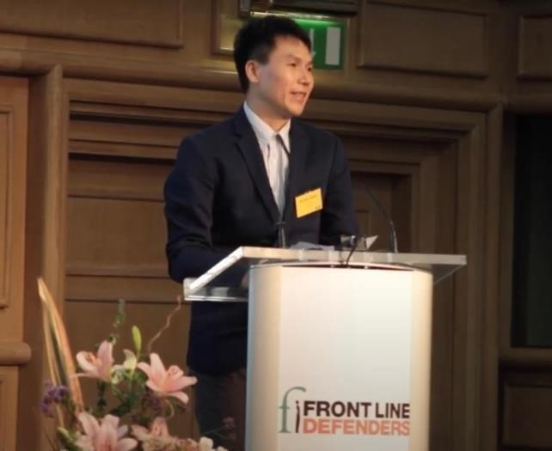
Do Nam Trung at the Human Rights Conference of Front Line Defenders in 2019

On August 30, activist Bui Van Thuan was arrested by security police in Thanh Hoa province for allegedly conducting propaganda against the state under article 117 of the 2015 Penal Code. Bui Van Thuan used to be a chemistry teacher at a number of high schools in Hanoi. Since 2013, Thuan has started using social networks to express his views on society and politics. He was a member of the Brotherhood for Democracy, and actively participated in protests against China's expansion. In recent years, under the severe repression of the authorities, many activists have had to limit their voices, but Thuan still constantly writes and shares policy criticisms on his personal Facebook page. Recently, Thuan has focused on writing about the unreasonableness of the government's anti-epidemic policy, the lack of consistency in the statements of Vietnamese leaders, including General Secretary Nguyen Phu Trong, on how to combat the epidemic. After Thuan was arrested, his family continued to be harassed. An ninh TV, a television channel of the Ministry of Public Security, broadcasted images of Thuan's wife and mother even though they refused to give an interview. The image of Thuan's family appeared in an ugly way, without having face blurred in a documentary titled "Beware of state opposing forces under the label of social criticism". According to information from the prison, Thuan signed the refusal to have a defense lawyer on October 12, then was hospitalized for health problems on October 15. The succession of events raised suspicions that Thuan was tortured during the investigation. It is common for defendants in political cases to refuse the right to a defense attorney. Some former political prisoners reported that they were coaxed into refusing a lawyer in exchange for not being beaten in prison or lighter sentences.
Independent journalist Pham Doan Trang did not receive adequate medical care during the investigation, despite having heart disease and ovarian cysts. She was only examined and given medicine after her lawyer met and filed a petition on October 19.
Doan Trang was tried at first instance on December 14, but was not notified in advance.
She only knew the date of the trial through her lawyer at the meeting on December 13.

b. Status of some other prisoners of conscience
Vietnam has regulations on inmates' rights in terms of diet, medical care, cultural, spiritual and religious activities in the Law on Execution of Criminal Judgments and related decrees. However, these regulations are in fact violated, making living conditions in prisons in Vietnam extremely harsh. The prison cells are not hygienic, the food provided is of poor quality, often rancid, making prisoners have to live on support from their families or deposit money. Inmates are entitled to use the money sent by their

families to buy things at the prison's canteen, but the prices here are always 4-5 times higher than the market price, creating a burden for the prisoners' families and prisoners themselves. Poor living conditions and lack of timely medical care make prisoners suffer from many illnesses. The situation is more intense when some prisons abuse their power in the pandemic.
According to statistics of the Vietnam Human Rights Network, as of June 2021, the Vietnamese government is holding at least 288 prisoners of conscience. These prisoners are often subjected to abuse in prison. Although Vietnamese law recognizes prisoners' right to make complaints, these petitions are often silenced, leading to more

abuse in return. Inmates only have a way to protest by going on a hunger strike to protect their minimal rights and that of other prisoners.
Prisoner of conscience Hoang Duc Binh informed his family on May 23, 2021 that he, together with Nguyen Bac Truyen and some other prisoners at An Diem camp,
Thanh Hoa, had been on hunger strike since May 12 to protest the prison’s torture of Nguyen Van Hoa and transferring this prisoner to solitary confinement elsewhere without notifying the other prisoners living with him.
Prisoner of conscience Nguyen Van Hoa is also reported to have many diseases and in need of a specialist medical examination. Although his family repeatedly petitioned the prison to ensure the rights of detainees, Hoa was only taken to the prison's infirmary to receive medicine.
On July 21, 2021, the family of prisoner of conscience Tran Huynh Duy Thuc reported that they were concerned about his life and health when Thuc might have been on a hunger strike for more than 120 days. According to his family, Tran Huynh Duy Thuc is expected to call home before July 20, however, the deadline has passed without receiving a call from the prison. Thuc had announced that he had been on hunger strike for more than 100 days in a phone call in mid-June.
Since June 2021, Xuan Loc prison in Dong Nai province has not allowed political prisoners to leave their cells day and night. Inmates protested this decision by refusing to accept meals provided by the prison, as it was a rare opportunity for them to mobilize

and leave the cramped cell. By the end of November, the prisoners here were still protesting, demanding to be released from the cell. Being confined in a confined space for too long can affect the physical and mental health of prisoners. At the beginning of the year, also at Xuan Loc prison, former prisoner Nguyen Van Duc Do was almost bitten by a police dog when he asked to go out of the cramped cell to exercise.
On November 30, the court of Buon Ho town, Dak Lak province issued a document "annulling the decision to postpone serving the prison sentence" for dissident Huynh Thuc Vy who was tried in 2018 after boycotting the Vietnamese National Day by spraying white paint on the red flag. Huynh Thuc Vy was sentenced to 30 months in

prison for "insulting the national flag" and had her sentence suspended because she was pregnant. Article 67 of the Penal Code 2015 stipulates that women who are pregnant or nursing a child under 36 months old may postpone the judgment execution until the child is fully 36 months old. If the convict continues to be pregnant or raise children under 36 months old, the judgment execution is still postponed until the last child is fully 36 months old. However, Huynh Thuc Vy suddenly received a decision to serve her sentence on November 30 and was sent to prison on December 1, 2021 when her last child was less than 36 months old. The decision of the court of Buon Ho town violated the legal provisions on the rights of convicts, besides, it also showed discrimination against dissidents, affecting the legitimate rights of children and families of this prisoner of conscience. At the time this report was written, Huynh Thuc Vy had been at Buon Ma Thuot Prison, Dak Lak Province for more than 1 month. Relatives are not allowed to visit her in person or send food, clothing, and medicine to her because of the camp's anti-epidemic regulations, nor can they talk to Vy by phone in accordance with the provisions of the Law on Execution of Criminal Judgments.

c. Revenge against police officer who denounced corruption

On April 14, Le Chi Thanh, 38 years old, a former police captain who had repeatedly denounced corruption in the police force, was arrested by the Thu Duc city police on charges of "resisting public officials" under article 330 of the 2015 Penal Code. Thanh used to work as a warden at Z30D prison in Binh Thuan province and was fired after denouncing corruption by the prison management. After that, Thanh and some friends used social networks to livestream, fighting petty corruption of traffic police on the street. At the beginning of this year, Le Chi Thanh expressed his attempt to selfnominate for the National Assembly on Facebook, although he did not submit his application. Many observers believe that the arrest of Le Chi Thanh was arranged to cover up the negative problem in the police force.

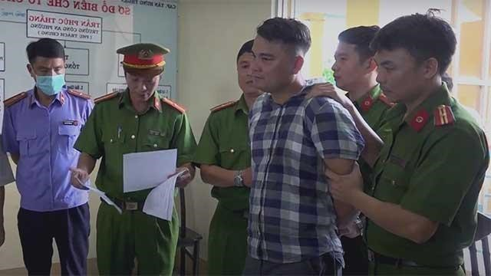
According to information from Le Chi Thanh's lawyer and family, Thanh's health has declined sharply since being detained, he lost about 30kg in 6 months. At an interrogation on October 19 2021, Thanh Le Chi Thanh at the time of his arrest reported in the presence of
his lawyer, the investigator and prosecutor that he had his hands and feet hung for seven days. All eating, drinking and urinating and defecating must have been done on the spot. He could only move three fingers on each hand, the remaining two fingers were paralyzed. Both of his legs had similar symptoms. His hands and feet were also tormented by scabies. This is an act of torture, degrading and inhuman treatment of prisoners, and these actions are most likely in retaliation for the accusations of corruption in the police force that Thanh made earlier. Le Chi Thanh is currently being detained at the City Police Detention Center. Thu Duc (HCMC).
Nguyen Doan Tu, a former officer of Z30D prison, is also exposing corruption of the Z30D camp's management. He was arrested on charges of "using corporal punishment against inmates". According to state media, an inmate at Z30D camp reports that he was beaten by Nguyen Doan Tu while on a job, and this complaint has been sent to the Supreme People's Procuracy. On December 13, the Supreme People's Procuracy ordered the arrest of Nguyen Doan Tu with pre-trial detention of 4 months and the removal of Tu from Binh Thuan to Ho Chi Minh City to further investigate. This arrest has many complications because Tu stood up to denounce the prison's exploitation of inmates' labor, causing injury and death. Mr. Tu's accusations about the systematic violations of Z30D prison were not thoroughly investigated by the competent authorities, but when there was a complaint that Mr. Tu beat an inmate, the Supreme People's Procuracy almost immediately prosecuted and arrested him. Before his arrest, Tu had sent a letter to the UN High Commissioner for Human Rights to describe the violations at Camp Z30D, the cover-up by his superiors, and the repression he suffered as a whistleblower.
Another police officer who has reported wrongdoing and is in a dangerous situation is Nguyen Duc Hung, who used to work at Xuyen Moc prison in Dong Nai province. Nguyen Duc Hung has denounced the corruption of the Xuyen Moc camp's management board in leasing land to businesses from 2018. After denouncing the wrongdoing, Mr. Hung was discriminated against by the prison management; by mid2021, he was officially expelled from the Party and stripped of his police citizenship. Like Nguyen Doan Tu, Mr. Hung was also accused by a person that he had an act of fraud and misappropriation of their property. The local police quickly took the case in and repeatedly summoned Hung to investigate the accusation. During a working session, a police officer revealed that they received orders from the provincial police to prosecute Hung.

d. Violence and unusual deaths
Vietnam ratified the United Nations Convention against Torture and Other Cruel, Inhuman or Degrading Treatment or Punishment in 2014. However, the state security forces continue to injure people in public places, or use corporal punishment while

incarcerated, sometimes cause deaths, without receiving any legal sanctions. It is worth noting that most of the deaths in police custody are usually related to minor problems, such as quarrels between neighbors, petty theft, etc. All death after being at the police station are said due to suicide or natural cause, while the families of the victims have recorded many traces of abuse and torture remaining on the victim's body.
Some cases of direct and indirect police violence were reported by the media:
- On January 6, 2021, Duong Quoc Minh (23 years old) died while incarcerated at Chi Hoa Prison, Ho Chi Minh city. Police said that Minh committed suicide. The family saw many bruises on Minh's body when they received the body at the City Forensic Center.

- On January 13, 2021, A Tram (31 years old) residing in village 12, Dak Ruong commune, Ko Tum province was found dead in a hanging position behind his house. Before that, he was invited by the police to work many times in relation to illegal logging.¹⁰
- On September 24, 2021, Phan Van Lan, 49 years old, Ha Lam commune, Da Huoai district, Lam Dong province, died on the way to hospital after 3 hours of working at the commune police station. On the morning of the same day, Lan had a quarrel with the police when this force made a sanctioning record for a green channel truck driver for violating the Covid prevention measure "1 road, 2 locations". Lan was taken to the police station with an accusation of insulting the police.
- On November 26, 2021, in the trial of the first instance department at the court of Binh Dan district, Vinh Long province, 4 defendants, including 3 juvenile

defendants, confessed that they were coerced and tortured during the investigation of robbery. Two defendants could not even walk and had to be escorted by the police.
- On December 29, 2021, N.V.K, 55 years old, residing in Nhon My commune, Cho Moi district, An Giang province was reported to have died of heart disease and stroke at the commune police station.¹²
During the UPR Periodic Review, cycle 3, 2019, Vietnam denied that police brutality was the cause of death for victims while in police custody. The representative of Vietnam said that the victims died because they were seriously ill before they were arrested, or it could be because "the prisoner is tormented by his crime, leading to pessimism and suicide".
Not only are there cases of violence in the police station, the public is also shocked with cases of violence and unusual deaths in the army.

Vietnam implements a non-compulsory military service for citizens between the ages of 18 and 27. According to the Military Service Law, the state makes the call for men to enlist once in February or March every year. The duration of military service in peacetime is 24 months.
The military service regime in Vietnam is not much different from that in many countries around the world, but the supervision and management of soldiers by the Ministry of Defense causes many controversies in Vietnamese society. Violence in the military, especially against young soldiers, is a matter of concern among many people and is the reason why many families give bribes in order to have their children out of the calling list.
Soldiers are classified according to their enlistment time and achievements. Higher ranks not only bring better treatment, but also the right to command subordinates. Thinking "military orders are mandatory" means that soldiers do not dare to disobey the commands of higher officers, even if these requirements are outside the scope of their

military duties. In addition, the military is considered as another world, away from the supervision of the media and public, leading to the fact that violent or negative incidents in the army are not exposed or handled appropriately. This makes young soldiers, especially conscripts - soldiers with the lowest rank in the army, becoming a weak, vulnerable group, some of them even lost their lives for no reason. In 2021, at least 3 young men will die while performing military service.
Tran Duc Do, born in 2002, hometown in Bac Ninh, was found dead in a hanging position on June 28, 2021 while performing his military service at Battalion 4, Company 14, Military University of Military Region 1 in Thai Nguyen province. The Ministry of Defense confirmed that the soldier committed suicide, but the family disagreed with this conclusion because there were many unusual wounds on the body.
Nguyen Van Thien, born in 1998, hometown in Gia Lai, died at the unit on November 29, 2021. Military forensics determined the cause of death was "stroke, falling, brain hemorrhage, pulmonary infarction". The state-owned media, citing a source from the Army, said that the forensic agency had obtained the consent of the family members before the autopsy, but in a clip of dialogue between the family members and the unit's representatives, the relatives of the victim questioned the military's voluntary dissection of the body without notifying the family. The initial press release of Gia Lai Provincial Military Command on December 1, 2021 stated that Thien tripped himself, causing brain hemorrhage and confirmed the bruises on his body were caused by a fall and the autopsy process, not because of a fight. However, state media reported on January 5, 2022 that the military's criminal investigation agency prosecuted the case and charged three defendants with "intentionally causing injury."
Hoang Ba Manh, born in 2001, hometown of Hai Duong province, died while performing his military service at an Air Force Defense unit in December 2021. State media has not yet published any information about this death. The incident became known to the public when a person claiming to be a neighbor of the victim's family

posted on social media a clip recording the conversation between victims' families and military representatives. In the clip, Manh's family confirmed that he died in his bed after being beaten, and the military unit promised to investigate the incident.
The common point of these cases is that the family members of the victims are upset because the cause of death is unclear, and there is suspicion of bullying and fighting in the army. These soldiers were all in good health, regularly kept in touch with their families and through conversations, they all showed a stable psychological and mental state. All of the families reported that they were forced to bury their bodies before all doubts were resolved, and the military always promised to thoroughly investigate the case after the funeral.
State media hardly reported or only quoted the military's conclusions, ignoring the sharing and questions of these soldiers' families. When the victim's family posted information on social networks, those posts were removed or blocked almost immediately. Pro-government commentators are also deployed to comment on major forums in favor of the government, monitor negative comments to report and delete.
In particular, in the case of soldier Tran Duc Do, after state-owned online newspapers stopped reporting, some Facebook fanpages attempted to update both sides of the story. Fanpage Hanoi leads in two-sided reporting, sharing the family's suspicion

of injuries on the body, how the government and military press and coerce the family to remain silent, and how the family was prevented from sending the body to the morgue for cryopreservation. Unfortunately, after 1-2 days, this fanpage issued a notice to issue a notice that it would no longer be reporting due to "great pressure." Comments and individual’s opinion related to the incident were also tightened. The police have summoned some people and asked them to promise not to write anything else or face administrative sanctions. Others have had their Facebook accounts deactivated because they "violated community standards."

3. The right to participate in political life
The elections for National Assembly deputies and People's Councils at all levels took place in 2021. This five-year election is a unique opportunity for people to directly exercise their right to participate in political life through voting and self-nomination. National Electoral Council announced that the election went very well with 99.60% of voters nationwide voting. The law stipulates that candidates are screened by the Fatherland Front, selected through consultation, and solicited voters' opinions. Among the 500 elected National Assembly deputies, only one case was not confirmed because of violating the Party's charter. 14 people who were non-Party candidates were elected, and the remaining seats in the National Assembly belonged to Communist Party members. There are 76 self-nominations nationwide, 4 of which have been elected and they are all Party members.
Even during the pandemic, the election was still held in the form of paper ballots directly at residential areas. There were mobile ballot boxes at hospitals and quarantined places for people suspected of being infected with Covid-19. A voter can vote in place of a few others, and local governments are always looking for ways to make sure all eligible voters deliver their vote. According to the electoral law, the counting of votes is carried out at polling stations located in residential areas in the presence of two noncandidate voters. There is no independent organization that monitor any election period in Vietnam. These practices always raise doubts about the substantive outcome of the election.
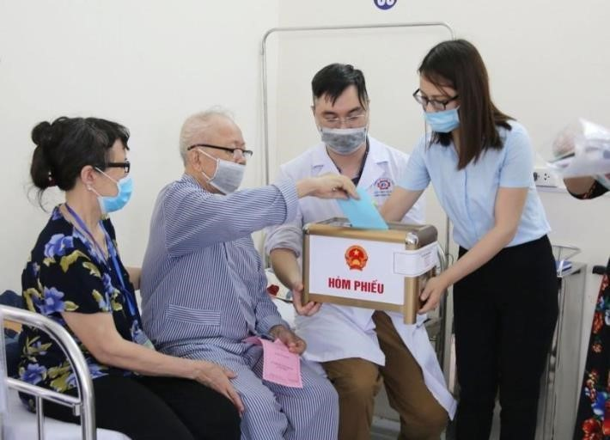

Mobile ballot box at Quang

Ninh General Hospital

(source: Quang Ninh Provincial General Hospital)

Like the 2016 election, many activists, citizen journalists, and academics have registered to run for parliament deputies. These independent candidates declare their intentions on social media and use this communication tool to promote their campaign positions and policies. There are two self-nominated candidates who used social networks to publicly run for election and attract attention: citizen journalist Le Trong Hung and social activist Luong The Huy - who belongs to registered NGOs. Like other completely independent candidates, these two were not elected and were subjected to a systematic campaign of repression from the authorities.

a. Independent National Assembly candidates are systematically suppressed
The government is no longer reserved as in previous elections when they eliminated independent candidates through administrative procedures, rounds of consultations and constituencies. Independent candidates this year and those who intend to stand for self-nomination are blatantly suppressed.
Tran Quoc Khanh was arrested by the security agency of Ninh Binh province on March 9, just a few days after he publicly announced on social media that he would selfnominate for national deputy. Khanh is also known as a voice disagreeing with the views of the Communist Party of Vietnam and frequently speaking out on social issues. He was tried on October 28 for having "22 videos with content that distort, defame the people's government, and create confusion among the people"., and was sentenced to 6 years 6 months in prison and 2 years of probation.
On March 27, 2021, Le Trong Hung was arrested under article 117. Hung is one of a small number of liberal parliamentary candidates who have a specific action plan and campaign by donating copies of the Vietnamese Constitution to the community. Before that, Hung often used his personal Facebook page to share his knowledge of the Constitution and the law. He also assisted in consulting and writing complaints to help people who unjustly lose their land. Hung was tried on December 31, 2021 and sentenced to 5 years in prison and 5 years of probation.

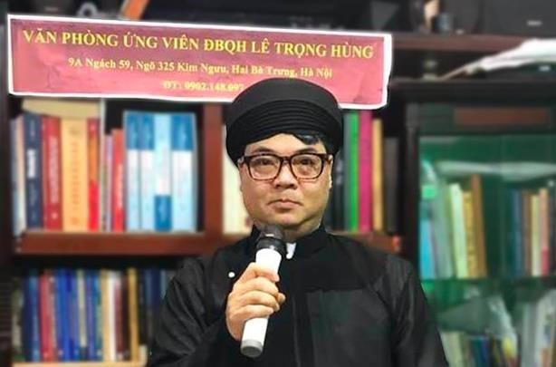
Le Trong Hung, an independent candidate, was arrested on March 27, 2021

Le Trong Hung and another activist, Le Van Dung, run an independent news site called CHTV on Facebook and Youtube platforms. Le Van Dung is also one of those who publicly intends to apply for self-nomination for the National Assembly this year. Dung was detained by the Hanoi security agency on March 19 and released the same night, however, he was officially arrested on June 30, 2021 on charges of conducting propaganda against the state under article 117. Currently Dung is still being detained for investigation.

A Cham ethnic poet, Nguyen Quoc Huy, was arrested by the police on April 7 and detained for several days without a warrant to question his declaration of selfnomination for the National Assembly. At least 5 other people were also arrested and interrogated by the police for participating in discussions with Nguyen Quoc Huy. Activist Nguyen Van Son Trung, who was involved in the case, reported that the arrest unfolded like a kidnapping. No arrest warrants were issued, and he was handcuffed and questioned about two friends' posts of self-nomination. Trung and the others were both released after a few days of interrogation, and were forced to sign a pledge that they had voluntarily worked with the police.
In addition to the above independent “reactionist” activists, this year's independent candidacy also has a representative from the legitimate NGO bloc, Luong The Huy. Huy can be considered the most prominent face among self-nominated candidates in terms of expertise, independence and legitimacy (in the sense that he has no direct conflict with the interests of the authorities). He is a Gender Policy Specialist, Director of the Institute for Social, Economic and Environmental Research ISEE. He won a lot of support from social activists in the country, the LGBT community and a number of young people. For the above reason, it would be very difficult to understand if Huy was eliminated in the consultation rounds organized by the Fatherland Front. Therefore, during the election campaign, Huy has suffered a heavy cyberspace attack targeting his sexual orientation, slandering his connections with reactionary organizations and individuals at home and abroad. There is a lot of evidence that the attack on Huy's reputation and honor was carried out by pro-government trolls and under the direction of the Propaganda Department.
The attacks, campaigning not to vote for Luong The Huy took place most in Ha
Dong and Hai Ba Trung districts of Hanoi where Huy was running for election. Fanpage
Ha Dong Silk Country (Quê lụa Hà Đông), a forum established under Project 132-
DA/TG of the Propaganda Department of Ha Dong District’s Party Committee to guide

public opinion in the online environment. released many posts aimed at sexual orientation, spliced Huy's statements to smear his reputation and promote baseless

accusations, calling the community to boycott Huy. A voter in Ha Dong district reflected on the neighborhood group's campaign not to vote for Luong The Huy by sharing defamatory posts, the image of him with a red X sign in the residential cluster's zalo group.
The civil society sector immediately responded to the wave of online repression with forums and Facebook posts calling on people to pay attention to Luong The Huy's action program and vote for this candidate. However, the fact that Huy missed both the positions of the National Assembly deputies and the Hanoi City Council deputies is predictable when the vote counting process lacks independence, and the authorities took no action to prevent falsely rumoring and smearing this candidate.

b. Citizens are forced to exercise their right to vote
Voter turnout rate in elections in Vietnam is always announced at an almost absolute level, despite many doubts in the statistical methods. To justify this number, the government has used many different methods and measures to force voters to vote.
Vietnam's Constitution and Law on Elections stipulate that voting is a citizen's right, but state media always quote state officials as asserting that voting is also "the duty and responsibility of citizens in perfecting the rule of law".
The Law on Election does not allow voters to write or cast ballots on behalf of others unless ones are unable to write themselves, or if a person with a disability is unable to come to the polling station on their own. However, writing and voting on behalf of the household members take place regularly and in all provinces.
A lot of people shared on social media about being forced to vote as a group representing local authority came to their homes or called on them to vote. If ones refuse,

they may be put on a local “black list” and face difficulties in administrative procedures. Some people who refused to vote after the election team went to campaign in person were asked to sign on a protocol, although the law does not stipulate this type of protocol or its legal validity.

Tuoi tre Thu Do, Ha Dong Youth actively fight against false claims on social networks (January 26, 2019), https://tuoitrethudo.com.vn/tuoi-tre-ha-dong-tich-cuc-dau-tranh-chong-lai-luan-dieu-saitraitren-mang-xa-hoi-38021.html
An anonymous post on a confession forum attributed to students of Hanoi Law University reflects that the school forces students to vote and uses that as a basis for graduation. Many people said that they had to make similar requests. Some students also commented that the school required them to take a check-in photo at the voting place, write a post with photo and hashtag on social media and return the voter identification with a “voted” confirmation stamp. Through discussions with a number of people, we have confirmed the practice that some universities force students to vote exists in Vietnam in many different forms. If students do not comply with the requirements or protest against it, it is very likely that their academic achievement and career opportunities will be affected.

4. The rights of children
Vietnam ratified the Convention on the Rights of the Child in 1989, and is always proud to be the first country in Asia and the second in the world to join this convention. In 2016, the National Assembly passed the new Law on Children No. 102/2016/QH13 to be better in line with the provisions of the CRC.
However, the concept of a child in Vietnamese law is still not compatible with international law when it defines children as people under the age of 16, creating a gap in the legal provisions relating to people aged 16 to under 18. There are many policies that group children 16-17 years old are not entitled to, such as those on legal support; policies on tuition fee exemption and reduction for poor and disadvantaged children; policies to support health insurance, medical examination and treatment for children with serious diseases requiring long-term treatment. This group of children has not been recognized to have the same rights and obligations according to the provisions of current law as those aged 18 years or older, and is not considered as children in order to be protected and fully enjoy the rights groups according to the provisions of CRC. This practice partly affects the development ability of this group of children.
According to the Law on Children 2016 and Decision No. 856/QD-TTg in 2017, Vietnam has 18 agencies, organizations and groups of organizations with the function of protecting children's rights at different levels and among ministries. In particular, the inter-ministerial agency at the central level responsible for supporting child protection is the National Committee on Children, which was established in 2017. In addition, Vietnam also has a hotline 111 to receive information on child rights violations, provide psychological, legal and policy advice to children and their caregivers.
Not denying the government's efforts to take care of children over the years in universalizing education, vaccinating babies, etc., but at the same time, it must be affirmed that violence and abuse of children is still a serious problem in Vietnam.
Physical or mental punishment is still accepted as a way of educating discipline in Vietnamese culture. According to the Sustainable Development Goals Survey on Children and Women 2020-2021, up to 70.8% of children under the age of 15 have suffered at least one form of psychological punishment (such as shouting, scolding, calling children stupid, lazy or similar) or physically (hits the body with hands or other objects) by household members in a month prior to the time of the survey. According to a report by the Ministry of Labor, War Invalids and Social Affairs, from June 2019 to June 2021, more than 4,000 children were abused, of which more than 3,600 were girls. There are more than 2,600 cases of child abuse between the ages of 13 and 16, accounting for more than 66%. In particular, there are more than 293 cases of children under 6 years old being abused. This number tends to be higher next year than the previous one.
Children's rights in general are still not properly respected by the police and society. Vietnamese law recognizes that children have the right to have their birth and nationality registered, and authorities are obliged to ensure this right. However, a lot of families in the Central Highlands report that they often face difficulties and are threatened not to receive birth certificates for their children, or other administrative

documents such as marriage or death certificates for religious reasons. This is one of the frequent acts of intimidation that the police use to oppress ethnic and religious minorities.

Legal procedures for persons under 18 years of age are specified separately in chapter 28 of the 2015 Criminal Procedure Code. According to the law, preventive and coercive measures such as custody and temporary detention are only carried out in real necessity and when other surveillance and containment measures are ineffective with consideration to the best interest of a child; Persons from full 16 years old to under 18 years old may be arrested, detained or detained if they are prosecuted, investigated or tried and if they continue to commit crimes, flee and are wanted (Article 419).
Despite letters of the law, there are many times when the investigative agency clearly violates the procedural principle without being held accountable. A case of juvenile procedural violation recently occurred with four defendants, including Nguyen Chi Hai (19 years old), N.H.N. (17 years old), N.M.K. and T.T.D (both at 15 years old) in Vinh Long province. These four defendants are accused of committing a total of 6 robberies of a 12-year-old child with a total amount of VND 14 million. Nguyen Chi Hai and N.H.N. were detained in pre-trial detention and subjected to coercion and torture during the investigation. During the first-instance trial on November 26, 2021 at the court of Binh Tan district, Vinh Long province, these two defendants could not walk on their own and had to be assisted by two judicial policemen. The two defendants N.M.K. and T.T.D. testified in court that they witnessed the Chief of Police of Tan Luoc commune, Binh Tan district grab N.H.N.'s hair, pulling his head backward when the accused were giving testimony at the police station on April 29, 2021. N.H.N. testified that he was questioned late at night by the investigator without the presence of his parents or his lawyer. The defense lawyer also pointed out 120 irregularities in the conclusions of the investigation and violations of the principles of criminal procedure. Rejecting the defendant's complaint and the lawyer's argument, the representative of the Procuracy said that testimony was taken in accordance with legal principles because "at the time of the complicated epidemic, the police force had to deal with lots of criminal denunciations, so they did not can wait", and the act of pulling hair is a criminal
"investigation tatic". N.H.N. was arrested and detained because he changed his

testimony and refused to admit the crime after being able to go home between the interrogation on April 29 and May 2.²⁴ The trial panel debated the verdict until December 2, 2021, then confirmed that the investigating agency and the Procuracy had followed the correct procedure and law. The court sentenced all four defendants to prison, of which N.H.N. (17 years old) was sentenced to four years in prison, each of 15-year-old defendants received three years and six months in prison.
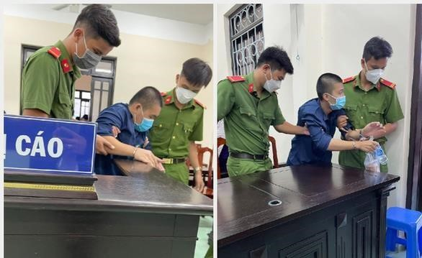
Policemen escorted defendant N.H.N. (17 years old) in the first instance court on November 26, 2021 at the People's Court of Vinh Long province (Source: Chi Hanh – Tuoi Tre Online)

Regarding children's privacy, Article 414 of the 2015 Criminal Procedure Code recognizes important procedural principles such as: ensuring privacy and the best interests of persons under 18 years of age. In fact, during the investigation process, children's privacy is often not kept confidential, especially for children who have conflicts with the law. Personal information such as names, places of residence, and

even photos are usually published in the press. In some cases, information of children who are victims or related to the case is leaked from the authorities. However, agencies

with a duty to protect children's rights often react very slowly, and do not take enough action, such as tracking the leaking source of information to prevent similar incidents.
Bong Lai Retreat (Tnh tht Bng Lai, also known as am bên b v tr) is a place of beliefs and religions practiced in Duc Hoa district, Long An province, founded in 2014 by Le Tung Van (90 years old). This retreat is home to a large number of children and the elderly. Many people have accused Le Tung Van and the Bong Lai Retreat of profiting from religion, fraud, and even incest from 2019 to the present. Due to these rumors, society focused on the children who lived here, many of whom were under the age of 18. A lot of youtubers and facebookers have come to the retreat to film and take pictures in order to gain online views, which has disrupted the lives of those staying there.
People posted and shared information, pictures, and names of children in the retreat after learning that Le Tung Van and Tinh That Bong Lai were prosecuted and investigated by the police on January 5, 2022. An image of what is believed to be a DNA test confirming that Le Tung Van is the father of many of the children went viral on social media as well. For several days, posts cursing Van with images and information about children were widely shared. The Children Department under the MOLISA immediately asked people not to share information and protect the children's privacy. However, so far, the information about the images of the children continues to spread widely, and other competent authorities still remain silent. Even the police department, which is always on the lookout for every move on social media and is in charge of protecting personal information and citizens' secrets, has yet to take appropriate and prompt action, as is often seen for government-related speech.

5. Socio-economic rights

a. The right to work and the right to an adequate standard of living
The right to work and the right to an adequate standard of living are two basic human rights belonging to the group of economic, social and cultural rights, enshrined in the 1948 Universal Declaration of Human Rights (UDHR), the 1966 International Covenant on economic, social and cultural rights (ICESCR), and have been codified in Vietnamese law.
According to Articles 23, 24 and 25 of the UDHR 1948, the right to work is not only the freedom to work without discrimination, but also to receive a share from the employer in the form of profits and other social supports. If the right to work is associated with remuneration, unemployment policies to ensure that everyone has a stable, developed life and an existence worthy of human dignity, then the right to an adequate standard of living has been specified into everyone's conditions of existence, such as ensuring the health and well-being of themselves and their families in terms of food, clothing, shelter, healthcare, and necessary social services. This right also extends to the right to unemployment insurance, sickness, disability, old age, ... or lack of means of living due to objective circumstances, and pays special attention to the rights of mothers and children.
Ensuring the right to work and the right to an adequate standard of living of workers cannot be comprehensive without the role of workers' representative organizations. ICESCR requires member states to guarantee the right to form and join trade unions and unions (article 8 of ICESCR). To date, Vietnam is not only a member of the ICESCR, ICCPR, but also ratified 21/189 ILO conventions on the right to work, including ILO Convention 98 relating to the right to collective bargaining.
During the epidemic situation, Vietnam's economy stalled, jobs, livelihoods and living conditions of many people were strongly affected. According to a report by the General Statistics Office, in 2021, a longer and more complicated epidemic situation in 2020 has caused millions of people to lose their jobs, and labor in different industries will continue to decrease, especially in the service sector. The number of workers in both formal and informal sectors decreased. The number of employees in the informal sector is 19.8 million people, a decrease of 628 thousand people, this decrease is higher

than that of workers with formal jobs; the number of employees with official jobs is 15.4 million people, down by 469.8 thousand people compared to the figure of 2020.

To support those affected by the pandemic, the Vietnamese government has launched stimulus packages for businesses and financial support packages for affected workers which are worth trillions of VND. Up to now, the government has had 3 rounds of supporting workers and people in difficult circumstances directly in cash, however, this payment is still inadequate and unfair. The support money is distributed through the representative of local authority and only the people on the support list will receive the money. Many people have reported that they have not received the support without any explanation, even though they have applied according to regulations. Some people, after raising concerns about the support online, were summoned and questioned by the police as their behaviors showed signs of violating the Law on Cybersecurity.

b. Strikes and union rights
In 2021, the provinces in the southern region are the most affected by the epidemic and must be closed down for several months. Ho Chi Minh City, Binh Duong, and Dong Nai continue to lead the country in terms of infections and deaths.²⁶ In order for factories to continue to operate in a state of blockade, the government has proposed a policy of "3 on-site" and "1 road, 2 locations". Accordingly, if businesses want to keep producing, they must make arrangements for employees to work, eat, and rest onsite. Employees who want to go to work must stay in a concentrated area of residence and are not permitted to leave or return home.
This policy, after a period of time, revealed many problems and did not guarantee the dual goals of "fighting the epidemic and developing the economy". Businesses have to spend a large amount of money to ensure epidemic prevention, rent housing for employees, provide essentials, and organize regular covid screening tests. Workers are not allowed to return to their families, but they are still at high risk of infection due to lack of vaccination. Many factories, after a period of "3 on-site" implementation, had experienced outbreaks and were forced to close in isolation, causing the costs of

businesses to be pushed higher, but the rights of workers accordingly decreased. As a result, workers in some businesses went on strike:
- On February 25, 2021, about 8,200 workers working for Simone Tien Giang Company, Tan Huong Industrial Park went on strike, demanding an increase in wages and working conditions.
- On July 29, RFA posted a clip recording the scene of police firing two shots into the air in front of a factory gate in Tan Binh industrial park, Bac Tan Uyen, Binh Duong. The purpose of this shooting was to prevent the workers from leaving the industrial park. According to RFA, the workers wanted to stop implementing the "3 on-site" policy (i.e. eating - sleeping - working at the company) because there were many new infected cases in the factory.
- On January 7, 2022, hundreds of workers of PouChen Vietnam Co., Ltd. in
Dong Nai province suddenly stopped working, spilling out onto the gate and National Highway 1A to protest the company and claim benefits. According to the press, workers here do not agree with the salary bonus in 2022 and require that the bonus level should be equal to 2021. On January 6, 2022, PouChen company announced the salary bonus for Tet holiday from 1 to 1.54 times of monthly salary, while the bonus for employees at this company in 2019 and 2021 is 2.2 and 1.9 times of monthly salary, respectively. PouChen Vietnam Company currently has the largest number of workers in Dong Nai province with 16,000 people. In July 2021, the company had to close due to detecting a local outbreak, and in October, the company reopened production activities. The incident at PouChen company caused a traffic jam, the police force had to be present to stabilize order.
The above incident contributes to demonstrating the practical need for a representative organization of workers to harmonize the interests of employees and employers. Previously, in Vietnam, only the Trade Union under the General

Confederation of Labor was considered the legal representative organization of workers,

performing the functions of collective bargaining and ensuring the interests of union members. However, the Trade Union is a socio-political organization and is under the leadership of the Communist Party of Vietnam, and in the above incidents the role of this grassroots trade union is completely absent. The Labor Code 2019, which took effect from the beginning of 2021, has allowed the establishment of workers' organizations at enterprises (workers’ representative organization - WRO), a representative organization of workers but independent from trade unions.
The establishment of such an independent union in enterprises is still a theory when more than 2 years after the new Labor Code was passed, and 1 year after the law took effect, the government still owes employees decrees and documents guiding the establishment of a WRO. The lack of procedural guidelines makes it impossible for workers in need to establish their representative organizations, and at the same time, the unions that are formed may face the risk from the authority for illegal gathering.
In addition, the government's excessive fear of “multi-union leading to political pluralism” is also a reason why the promulgation of regulations is forever deadlocked. At the urging of the international community, social organizations at home and abroad, the mouthpiece of the Ministry of Public Security - the People's Public Security newspaper has gone against the international commitments of the government on the substantive guarantee of workers' rights to freedom of association and collective bargaining. The article has linked WROs with the form of anti-Party and anti-State association and called on workers to actively join state unions, boycott the establishment of independent worker’s organizations.

c. Ensuring human rights principles in EVFTA
The EU-Vietnam Free Trade Agreement (EVFTA) is a new generation FTA between Vietnam and the 28 EU member states. The agreement was signed in 2019 and officially took effect on August 1, 2020.

Although the EVFTA is a trade agreement, human rights commitments play a significant role. Not only does EVFTA reaffirm the commitments in the United Nations

Charter and the principles in the 1948 Universal Declaration of Human Rights UDHR, but it also states that economic and trade cooperation between the parties must be based on the principles affirmed in the Partnership and Cooperation Agreement (PCA) signed by Vietnam and the EU in 2012. Article 1 of the PCA affirms the parties' commitment to "respect for the principles of democracy and human rights, as enshrined in the United Nations General Assembly Declaration of Human Rights and related international human rights instruments," which is "an essential element of this agreement."
As a new-generation trade agreement, the EVFTA emphasizes the third generation of human rights, that is, rights related to the environment and labor. Chapter 13 of the EVFTA, titled Trade and Sustainable Development, clearly stipulates the responsibilities of both parties in acknowledging international standards and principles on environment and labor, and at the same time, committing to protect the values acknowledged by both parties. To ensure that EVFTA can achieve its goal of promoting human rights in Vietnam, Article 13.15 requires each party to establish one or more domestic advisory groups (DAG) with independent members from economic, social and environmental fields, including workers' and employers' organizations, enterprises and environmental organizations. The DAG mechanism is expected to support civil society’s participation and influence in the implementation of EVFTA, in which, ensuring that the EVFTA strengthens and promotes human rights values as pillars of sustainable development.
After the EVFTA officially took effect, the EU DAG mechanism was established at the end of 2020. Meanwhile, DAG Vietnam was officially established on August 17, 2021 through Decision No. 1972/QD-BCT of the Ministry of Industry and Trade (MIT).
This decision stipulates quite clearly the functions, tasks, organizational structure and

operation of the domestic consulting group. Accordingly, DAG Vietnam acts as a forum, gathers and presents views, gives recommendations and advises on the implementation of chapter 13 EVFTA. DAG Vietnam consists of no more than 15 official members and some observers who are Vietnamese associations, NGOs and non-profit organizations,

capable of consulting on trade and sustainable development for the authority. In terms of independence, members and observers must act independently of the regulatory body to which the group provides advice. According to clauses 3 and 7 of article 3, members and observers will be selected, but the selecting authority and procedures are not specified in the Decision. Compared with the criteria set out by the MIT in the "Notice to receive information of interest in becoming a member of the domestic advisory group (DAG) in Vietnam for the implementation of the EVFTA Agreement" posted on the official website of the Ministry on October 5, 2020, the set of criteria for membership in Decision No. 1972 increased by 1 criterion: the organization must have no illegal activities before becoming a member of DAG Vietnam.
Three members of DAG Vietnam who were appointed immediately with the establishment decision are (1) Vietnam Chamber of Commerce and Industry (representative of employers); (2) Institute of Workers and Trade Unions, under the Vietnam General Confederation of Labor; and (3) Center for Sustainable Rural Development (SRD). On December 30, 2021, the Ministry of Industry and Trade issued a decision adding three more members to DAG Vietnam, including: Vietnam
Association of Seafood Exporters and Producers (VASEP), Vietnam Fisheries
Association (VINAFIS) and Education for Nature Vietnam (ENV).
DAG Vietnam was formed only in response to the urging of the DAG EU. The group lacks an independent voice, and is not diversified enough in terms of economy, society and environment as expectation for a real DAG mechanism. 3/6 current members of DAG are in the economic sector and 2 of them, VCCI and VASEP, represent

businesses and employers. The Institute of Workers and Trade Unions is an organization directly under and closely related to the Vietnam General Confederation of Labor, which is in fact an extension of the Communist Party to manage the working class and does not represent the true voice of workers. The presence of the Institute of Workers and Trade Unions in a mechanism expected to "benefit the people, not just the economic

giants" reflects the missing of a substantive representative organization to protect the interests of workers in Vietnam.

6. Anti-pandemic policy and human rights
When the new covid wave broke out around the world in 2020, Vietnam was one of the least affected countries thanks to its policies on isolating infected (F0), tracing and isolating those who have been in contact closely or indirectly with F0, etc. From the very beginning, these rigorous disease control methods have raised concerns about potential human rights violations. But in the name of "combating the pandemic", "protecting public health", "for the public interest", along with achievements in disease control, all violations were justified. When the epidemic broke out on a national scale in 2021, widespread human rights violations occurred and were difficult to justify in any way.

a. The government issued a series of unconstitutional policies
Vietnam's anti-pandemic policy from the beginning until now has been issued through Directives, official dispatches of the Prime Minister, local authorities or oral instructions from leaders. Prime Minister Nguyen Xuan Phuc during his term issued Directives 15, 16 and 19 on pandemic prevention and control measures, ranging from stopping mass gatherings, suspending some business activities, to isolating the whole society, people are only allowed to go on the road when necessary. Applying Directive 16 is the highest anti-epidemic level with the requirements that gathering no more than 2 people, people can only go out when there is a necessary reason.

From a legal perspective, these written policies are not considered to be law and are not binding on everyone. According to Article 4 of the 2015 Law on Promulgation of Legal Documents, directives of the Prime Minister are not included in the list of 15 types of legal documents. According to article 30 of the Law on Organization of the
Government 2015, “The Prime Minister signs documents on behalf of the Government; issue decisions, directives and instructions, inspect the implementation of those documents…”, which means that the Directive cannot be used to impose mandatory

codes of conduct for all subjects in society, but is only a practical guiding document within governmental sector.
To justify the legitimacy and authority in issuing directives, the government asserts that the extreme social distancing measures in Directive 16 are to persuade and mobilize people to voluntarily take measures to protect themselves and their families. However, the content of Directive 16 and the Implementation Guide uses imperative words such as "required", "only" "must", "strictly implement",³⁸ which obligates subjects in society to comply. Along with the provision requiring "severely handling violations", it can be seen that the Office of the Government - the agency that drafted the Directive - had confusion and misunderstanding about the nature and validity of the document.
Also according to the incumbent Prime Minister at that time, Nguyen Xuan Phuc, the measures of Directive 16 were "pre-emergency" solutions. This is a new phrase created during the pandemic, which has never appeared in any documents and has not been explained by the body that has the function of making laws (the National Assembly) and interpreting the laws (the Standing Committee of National Assembly). The term most closely related to the nature of the epidemic prevention directives is the "state of emergency", which is provided for in the Constitution and related laws.

A notable legal event was the first session of the 15th National Assembly regarding the legitimacy of executive power in July 2021. Accordingly, the 15th
National Assembly issued a resolution granting the government the right “to apply measures in a state of emergency to promptly prevent the spread of the disease; and to decide and organize the implementation of measures that has not yet been prescribed by law or different from those in current laws and ordinances to meet the urgent requirements of COVID-19 epidemic prevention; and control on the application of special and specific mechanisms, especially in licensing, pharmaceutical production, medical equipment and public procurement to prevent complicated epidemics.” The

Government is allowed to take special measures until the end of December 31, 2022 and must report to the National Assembly on the application of the above measures. However, nowhere in the full text of this resolution No. 1 directly declares a state of emergency, the most important basis for restricting basic human rights in Vietnam.
Issues related to the state of emergency mentioned in the 2013 Constitution of Vietnam include the following: First, the only entity with the right to regulate the state of emergency is the National Assembly (Article 70.13); Second, the subject competent to declare a state of emergency is the Standing Committee of National Assembly (Article 74.10); Third, the subject with the right to declare a state of emergency is the President (Article 88. 5); Fourth, the State has the right to expropriate or requisition with compensation the properties and land of organizations and individuals at market prices, in case of an emergency situation (Article 32.3 and Article 54.4). Fifth, human rights and citizens' rights can be restricted only in accordance with the provisions of the law in case of necessity for reasons of national defense and security, social order and safety, social morality, etc.
The 2013 Constitution does not have specific provisions on what is an emergency, as well as measures to respond in an emergency. These issues are currently regulated in a number of sub-constitutional legal documents such as the 2000 Ordinance on State of Emergency, and other specialized laws. In the context of dealing with the pandemic, the basis for declaring a state of emergency may be in accordance with the provisions of the 2007 Law on Prevention and Control of Infectious Diseases.
According to Article 1 of the Ordinance on State of Emergency of March 23, 2000, the state of emergency is generally defined as: “When in the whole country or in many localities there is a major disaster caused by nature or man, an epidemic, dangerous diseases that spread on a large scale, seriously threaten property of the State and organizations, people's lives, health and properties, or there is a situation that seriously threatens national security, public order and social safety, the Standing Committee of the National Assembly or the State President shall declare a state of emergency to apply special measures in order to promptly prevent, limit and overcome the consequences, and quickly stabilize the situation". (The Ordinance on State of Emergency 2000 is a confidential document and is not publicly available in Vietnam).
Article 42 of the Law on Prevention and Control of Infectious Diseases stipulates the principles and authority to declare a state of emergency due to epidemics, accordingly a) State of emergency must be declared when disease spreads rapidly on a large scale, seriously threatening people's lives and health, the socio-economic of the country; b) The declaration of the state of emergency must be public, accurate, timely and in accordance with the authority. Clause 2 of this Article reiterates and concretizes the provisions in Article 74.10 of the 2013 Constitution, whereby the National Assembly Standing Committee has the power to issue a resolution declaring a state of emergency at the request of the Prime Minister; in case the Standing Committee of the National Assembly cannot meet immediately, the State President shall issue orders to declare a state of emergency.
According to Article 43 of the Law on Prevention and Control of Infectious Diseases, the contents of a state of emergency declaration during an epidemic include: Reasons for declaring the state of emergency; Areas under the state of emergency; The starting date and time of the state of emergency; Authority to implement resolutions or orders declaring a state of emergency.
International human rights law allows states to temporarily suspend certain fundamental rights enshrined in international human rights treaties (ICCPR and ICESCR) in the event of an emergency insofar as and not contrary to the nature of the rights. In particular, article 4 of the ICCPR explicitly requires member states to formally declare a state of emergency in order to be able to restrict some certain rights enshrined in these conventions.
Thus, according to international law and Vietnamese law, the state of emergency cannot be tacitly understood, but must be officially announced by a state agency. And the fact that the National Assembly of Vietnam passed a resolution granting more powers to the Prime Minister and the government in the prevention of the Covid-19 outbreak on July 28 is not equivalent to a declaration of a state of emergency when no one specific statement is made. The resolution itself also does not follow the content of a state of emergency declaration when it does not specify the date and time to start applying special measures. As a result, the government’s regulations on pandemic prevention, as well as coercive and sanctioning measures, have violated the Constitution.

b. Local government abuse of power
Until August 2021, there had been 25 provinces and cities that simultaneously applied Directive 16 in part or all of the province. Applying Directive 16, which is considered the highest level of anti-epidemic at present, requires all people to comply with strictest pandemic prevention instructions, such as staying at home and only going out when "necessary", and stopping all means of public transport. Based on the assessment of the local government on the situation in each locality, additional measures can be implemented. Curfew order can be imposed, people must carry full personal identifications, road permits issued by the authority or workplace to prove the purpose of travel, and only travel according to the route indicated on the road permit. Another extreme anti-epidemic measure is gathering F0, F1 (who have been infected and have a high risk of infection) in a concentrated isolation area, which actually pushes people to a higher risk of infection. Simultaneously, the large-scale quarantine has put enormous pressure on the already-stressed health care system, resulting in many people not receiving adequate health care nor being provided with adequate necessities when they are not allowed to do shopping for themselves.
The Vietnamese government applies heavy sanctions as a deterrent. Decree 117/2020/ND-CP stipulates provisions on penalties related to the pandemic, in which the fine level is from 1 million to 3 million VND for “acts of not taking personal protection measures for those conducting disease prevention activities and those at risk of contracting infectious diseases according to the guidance of the health authorities” to, which is 10 times higher than the previous regulation. This Decree also introduces a new clause that sanctions "acts of not complying with measures to prevent and control infectious diseases at the request of competent agencies and organizations" with a very high fine, from 5 million to 10 million VND. This is considered as a "scanning clause", in order to ensure the sanction of acts issued by other agencies such as the Ministry of Health, the provincial People's Committee issued documents to be applied locally.
However, documents from the central to local levels are inconsistent in interpretation, lacking specific content and experts’ consultation, leading to different ways of applying in different places. People on the street are afraid of being fined, but if they stay at home, they cannot receive road permits certified by the government. Some localities still maintain normal traffic conditions, but there are other localities that ban all traffic to go in or out, some even barricaded roads to prevent other locals from entering.
In Thanh Hoa, Hoang Thai commune authorities locked the gates of 278 households containing nearly 400 people within 14 days for "compliance with quarantine at home." Some neighboring communes have learned about Hoang Thai commune's "initiative", while people are deeply concerned about the risk of fire and explosion.
There were many clips circulating on social networks, recording the abuses of power by the authorities in the name of "anti-epidemic." For example, the clip recorded the image of some people wearing protective gear. Medical staff climbed the wall into people's houses, broke the door of the room to force people to go to concentrated isolation in Nghe An, or many other clips recorded the image of the police entering the house, dragging people to the ward to punish violations, forcibly send them away. test.
Many videos circulated on social media, showing authorities abusing their power in the name of "anti-epidemic." For example, there is a clip captured the image of some people wearing protective gear and medical staff climbed the wall into someone's private homes, broke the door and forced people to go to concentrated isolating places in Nghe An, or many other clips captured the image of police breaking into houses, dragging people to the police station to punish violations, and forcibly sending them Covid testing point.

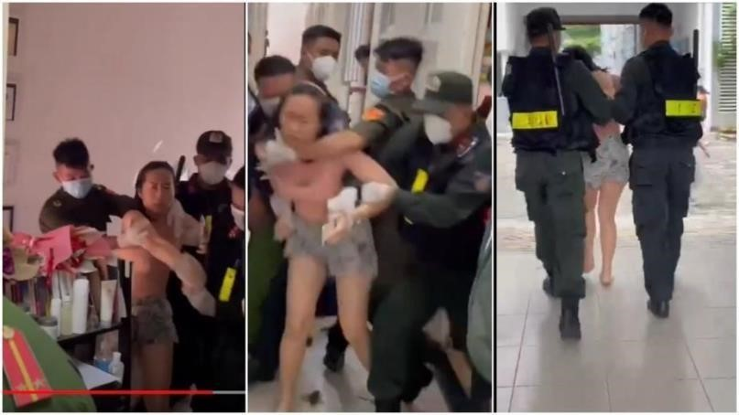
The authority broke into a private house and forced a woman to take a Covid-19 test on September 28,
2021 (Source: VnExpress)

For tighter control, the police, civil defense force, and even the army have been mobilized to set up barricades and punish people who go out without a reason of necessity. From July 9 to July 12, Ho Chi Minh City fined more than 12,000 cases of violation of Directive 16, adding 3.3 billion VND to the state budget. Hanoi announced an average of 1,000 violations per day in August. Among these sanctioning cases, there are many cases caused by the ambiguity in legal regulations, the difference in understanding of "essential goods" and "necessities" of law enforcement officers.
In a situation where local and central budgets have been greatly reduced due to anti-epidemic support, fines for those who go out without proper reasons is an attractive method to bluff and punish in a large-scale. A document from the authority of Ward 6, Go Vap District, Ho Chi Minh City, stated the target for the barricade located in front of the gate of the ward People's Committee was "20 cases per shift", and for the patrol team, the target was "5 fining cases each working shift". After the document was reported by the media, the Go Vap district government withdrew the above document and explained that the error occurred because they were "taking drastic measures to

prevent epidemics".Although only one locality has leaked illegal documents, this seems to be a common trend in many provinces and cities as controversial sanction cases occur everywhere. People who go to the street to buy bread, to the supermarket are fined, people who go out to withdraw money at ATMs are also fined, drivers carrying nonfood goods such as diapers, medicine, gas are also blocked and fined.⁴⁴
Even though people are extremely frustrated with the mechanical work of the authorities and the unreasonable high administrative fines, it was not until July 27, 2021 that the Ministry of Industry and Trade issued a document specifying the list of essential and non-essential goods to unify interpretation. However, there is no mechanism for the

fined persons to appeal the wrongfully administrative penalty decision and receive compensation.

c. The great evacuation in peacetime
Vaccines are scarce, but the policy prioritizes officials, frontline forces preventing the disease and the armed forces, teachers, and people working in administrative offices. Meanwhile, people living in the high risk area and workers, especially freelancers, who should be given the most priority in terms of risk of infection and disease transmission, are placed lower in the waiting list. These people are even
“elbowed out" by people who are not in the priority category but have money and connections. As a result, people at high risk of infection are not fully protected during the outbreak.
Workers in the southern provinces are mostly laborers from other provinces ưho go to industrial cities to work in factories, industrial zones and other jobs in the informal sector. They do not have a wide and friendly social network to help in the unfavorable situation. They themselves live in small dormitories that only meet the minimum living conditions and the monthly salary is not enough to create savings. When Ho Chi Minh

City began to apply continuous social distancing measures from May 31, 2021 to September 30, 2021, in which Directive 16 was applied from July 9, people could not go out to work, and did not know when they can go to work because the local government renewed directive 16 every 15 days. Hence, they were exhausted both physically and mentally after months under lockdown.
The government has provided support packages, but the way for the money to reach people is very long since they have to write an application with proofs attached. Government representatives at the grassroots level (heads of residential groups, village heads) are in charge of receiving registration applications and distributing money and food supplies from the government. And once again the controversy arose. Many residents reported that they had to sign a paper saying that they had received supplies even though nothing was given to them. Many laborers in difficulties waited for support money but neither received nor had any explanation. The government continuously

announced the disbursement of trillions of support packages and all people should have received support. Angry people went to the People's Committees of communes and wards to demand explanation and display protest banners asking for support. However, what they got is usually the evasion of local authority, or criminal charges of disorderly conduct.
To prevent the risk of riots in Ho Chi Minh City and other southern provinces, the government mobilized the largest number of army forces since the China war in 1989. The Ministry of National Defense said that over 130,000 soldiers were mobilized during the entire anti-Covid campaign. The force for pandemic prevention and control at the border alone was about 20,000 people, the rest of more than 100 thousand stayed in Ho Chi Minh City. Of these, nearly 77,000 soldiers were to ensure security and order, and to increase forces at checkpoints to control people's movement.

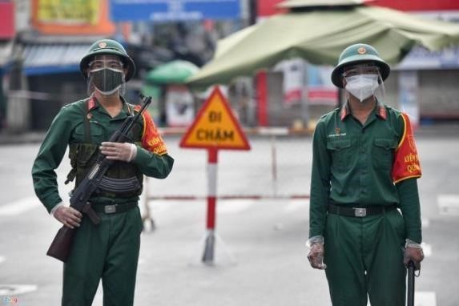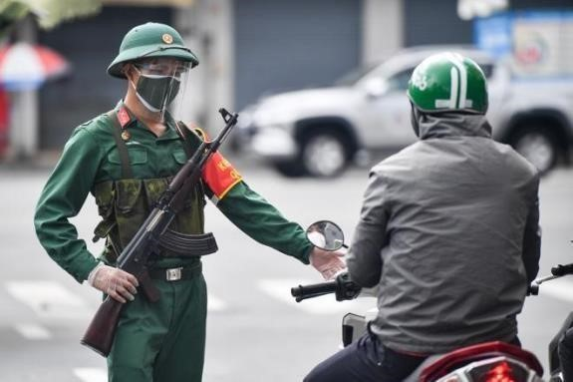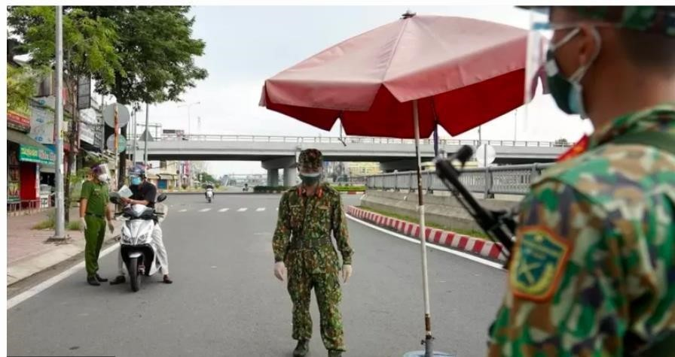

The army stands guard in Ho Chi Minh City (photo source: BBC News Vietnamese)
Exhausted after months of social isolation, workers in Ho Chi Minh tried to return to their home provinces. They were able to complete the journey, which spanned thousands of kilometers, thanks to the generosity and kindness of strangers. While people are hungry, afraid of being infected, and having difficulty traveling long distances, some of their home provincial authorities are concerned that these people will bring the disease back with them, so they have blocked people at the gateways. Some provinces in the Southwest region such as Ca Mau, Bac Lieu and Soc Trang have petitioned the Central Government and Ho Chi Minh City not to let people go home by themselves. At the same time, these provinces launched a slew of high-level epidemicprevention measures. And, while there is no ban, it is clear that with so many restrictions, it is difficult for people to return to their homeland.
Not only setting up checkpoints to prevent the flow of people back to their hometowns, the provincial authorities also prevent people from gathering on social networks and planning the journey to their hometown together. Specifically, on October 2, the Cybersecurity and High-Tech Crime Prevention Department, under the Binh Duong Provincial Police, summoned two people who were accused of using social networks to call for people to return to their hometowns in case of not receiving aid.
The inconsistent but draconian policies of the government during the recent Covid outbreak show not only the lack of management capacity, policy making but also achievement emphasis and the lack of trust of the authorities with the people. Because they did not believe that people would take measures to prevent virus transmission, the government imposed extremely heavy sanctions, set up checkpoints everywhere, and repeatedly blamed the public's consciousness when the number of new infections and mortality did not decrease. In the opposite direction, people also lose faith in the government. Since early October, when Ho Chi Minh City allowed people to leave the city, there have been long lines of people returning to their hometown, despite promises that those who stay will be vaccinated and provided more support.
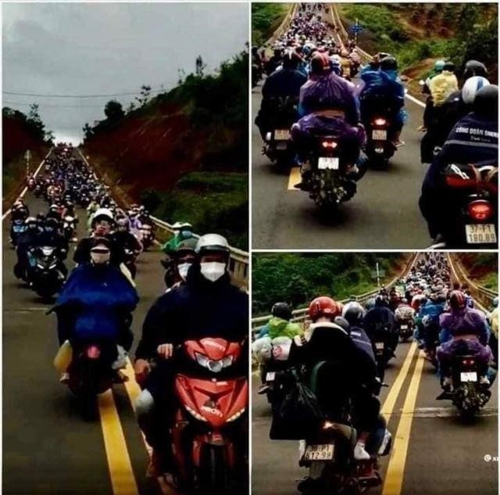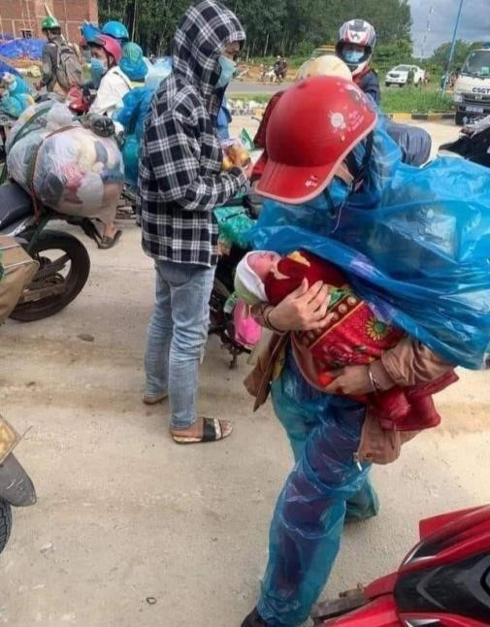

The flow of people running to their hometown on the A1 highway (source: BBC)

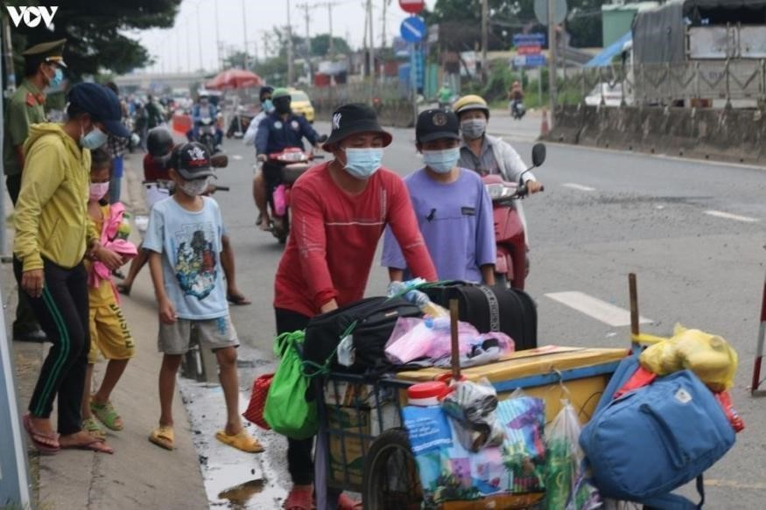
Poor families walk home (source: VOV)

c. The "Scapegoat" Renaissance Missionary Church
The fourth Covid outbreak in Vietnam started in April 2021 and despite new cases within the community, activities with large crowds and high risk of infection still took place normally. People traveled across the country on holidays of April 30 and May 1. On the election day of May 23, when the epidemic broke out strongly in the northern provinces, the state still resolutely held elections as usual. Even the authorities in Bac Ninh and Bac Giang provinces, where were having the highest infected cases, also cheered for their determination to organize successful elections in all epidemic situations. The officials brought the ballot box into the quarantine places, hospital, to the beds of the patients for them to vote on the spot. These two events can completely be the reason why the disease spreads throughout the country.
However, all the attention on the source of the disease was focused on a Protestant worship place, the Renaissance Missionary Church in Go Vap District, Ho Chi Minh city. From the three infections detected on May 26, this facility was blamed for spreading the disease throughout the whole city and neighboring provinces. The name of this church is constantly appearing on state-owned media news, along with the announcement of the increasing number of infections in Ho Chi Minh City. The domestic press rushed to report on them, revealing their identities, travel schedules, and exact addresses, even though the previous patients were all called by sequential numbers. The government's response took place in a row in just a few days: prosecuting the case (on May 30), requesting to suspend operations and withdraw the license to practice religious activities (on June 1). The Religious Affairs Committee also spoke up about the Church’s organizational structure and how they should have called the organization's name and religious dignitaries.
The prosecution by the police and the direct direction of the Ministry of the
Interior were both launched in hurry, imposing a "guilty" impression on the Renaissance Missionary Church while ignoring other objective factors. First, there is no evidence that this group hid information or violated epidemic prevention regulations, and this case is still under investigation. Second, the source of infection and the time of infection of these church cases is unknown, and at least one outbreak at VIB bank appeared at the same time as the outbreak in the church. Third, people who were considered a source of infection for many people in the previous outbreaks and also at the beginning of the 4th outbreak were not subject to criminal investigation. However, when there were cases of infection within a religious group, the case was immediately prosecuted.
While the number of Covid cases is increasing rapidly in many cities, blaming the Renaissance Missionary Church is both convenient and easy for the authorities in many ways. The church is a minority religious group, organized but not strong, and they do not have the power to refute state media. Making the church a target for public opinion will reduce attention to crowded events such as the recent election or the new identity card registration that the government is aggressively implementing.
Although the Vietnamese government affirms its policy of national and religious "great unity", and severely convict anyone who commits the crime of "undermining the great national unity bloc", the government's actions reveal clearly discriminatory. The police have yet to make a final conclusion after 6 months of investigation. And whether or not the church actually violated the epidemic prevention regulations to spread the disease, the church’s members have been violated the right to privacy and freedom of religion. The Vietnamese government cannot deny the violation of the principle of nondiscrimination and even the policy of great national and religious unity that they have always preached in this incident.

Conclusion

The year 2021 has closed with darkness covering most aspects of human rights in Vietnam, from freedom of expression, the right to participate and political life, to the right to employment and an adequate standard of living.
In just one year, three different groups of journalists were arrested and tried. The first one is the group of journalists who directly confront the government's unique interests, from the Independent Journalists Association of Vietnam IJAVN with Pham Chi Dung, Nguyen Tuong Thuy and Le Huu Minh Tuan to Pham Doan Trang - talented famous writers not only in the country but also in the international community. The next group is journalists from the mainstream, with certain reputation and achievements in the state-owned press system such as Mai Phan Loi, Tran Hoai Nam. And the last group is Clean Newspaper, with articles that deeply investigate hot social issues, representing writers who do not belong to the mainstream press system but also do not lean into the "reactionary" direction. They, despite expressing different political views, were arrested and received heavy sentences for daring to confront group interests at different levels in order to reflect information from many perspectives.
The government's grip not only tightens press freedom, but also controls the content of anyone's expression. A lot of people have been arrested over the past year for posts expressing directly or indirectly views about the government on social media. All were accused in a very vague manner by articles 117 (propaganda against the state) and 331 (abusing democratic freedoms). Meanwhile, the police, procuracy and courts have never fully demonstrated how and to what extent the defendants’ actions have infringed upon the legitimate interests of the state, organizations and individuals. Suppressing the free press and monopolizing media is the government's way of distorting the concepts of basic human rights in general, and freedom of expression in particular.
The 13th Congress of the Communist Party of Vietnam, which took place earlier this year, was "a great success", stated Nguyen Phu Trong, the re-elected General Secretary. He is considered a special case of personnel and is "trusted" to be assigned the position of General Secretary of the Party for a third term, despite the contrary to the Party's charter. Although Trong's re-election case surprised many observers, the public has spread rumors about Trong's continual in position, along with an exact list of three remaining important positions in the state apparatus. The leak of such "confidential" senior personnel information reflects the arbitrary arrangement stability among interest groups in the race for power seats.
Elections are still considered a sensitive time and people have more opportunities to pay attention to citizen’s rights than usual. As a result, the arrests, repression, and harassment of democratic and human rights activists often increase during this period. However, compared to previous elections, when the government still used soft measures to remove independent candidates from the official list of candidates, they have no longer hesitated this year and arrested many people on charges under article 117 of the Penal Code. Possibly because the top four leadership positions have been arranged, the internal political situation among elites is stable and the national elections in May are just a formality to legitimize state power. In such a context, the government no longer hesitates to intensify the repression of those who have and may intend to self-nominate to the National Assembly.
The Dong Tam incident happened 2 years ago, but the echoes of that attack still continue to this day. The elderly Party member Le Dinh Kinh, the only citizen who died that night, has not yet been issued a death certificate, and the appeal court in March 2021 ruled the case against 6 Dong Tam residents with 2 death penalties and 1 life sentence. A series of other trials and arrests targeted people who were directly or indirectly related to Dong Tam, from activists who helped the villagers after the night of the attack, people who directly criticized the actions of Mr. authorities to those who simply re-shared articles on social networks. Dong Tam case has gone down in history and will forever remain an indelible stain in Vietnam's human rights record.
In the second half of December 2021, the Vietnamese court held five consecutive court sessions, trialing seven dissidents. The Office of UN High Commissioner for Human Rights and other international organizations have expressed deep concerns about the repeated arrests and trials in Vietnam. Before the trial of journalist Pham Doan Trang, the UN Working Group on Arbitrary Detention concluded that the Vietnamese government had seriously violated international human rights obligations and demanded the release of Pham Doan Trang immediately and unconditionally. In response to the official opinion of the UN human rights agency, the Vietnamese authorities sentenced Pham Doan Trang to 9 years in prison.
The Vietnamese government's lack of international respect is also reflected in two arrests following high-level meetings with the United States. One is the arrest of independent journalist Pham Doan Trang on the night of October 6, 2020, which happened just a few hours after the Vietnam-US Human Rights Dialogue. The other is the arrest of activist Bui Van Thuan on August 30 2021, 3 days after the Vice President of the United States ended her visit to Vietnam. These two cases are not merely violations of human rights, but also represent challenging attitudes from the Vietnamese government.
In the context of Vietnam's attempt to get a seat on the United Nations Human Rights Council in the next term, the government seems to try creating a good image through diplomacy, by communicating about the drafting of a voluntary mid-term report under the UPR mechanism and the decision to grant amnesty to 3,000 prisoners on the occasion of National Day. However, the actual human rights situation in this country sends a cold message: despite international condemnation, the Vietnamese government can still do what they want; and despite international commitments, Vietnam has its own standards and among which, the most crucial human rights of all is to ensure that “people have rice to eat and clothes to wear.”

Appendix

Table 1. Arrests in 2020 (ordered by date of arrest)

No. | Name | Year of  Birth | Gender | Field of activity/group/ _{association} | Date of arrest  (DD/MM/YYYY) | Allegations under  article
1 | Cao Văn Dũng | 1968 | M | Facebooker | No information | 117
2 | Đặng Hoàng Minh | 1993 | M | Facebooker | No information | 117
3 | Trần Hoàng Minh | 1990 | M | Facebooker | No information | 331
4 | Trần Minh Chí | 1993 | M | Facebooker | 04/01/2021 | 331
5 | Y Bi Mlô | 1969 | M | Facebooker | 04/01/2021 | 331
6 | Nguyễn Trí Gioãn | 1979 | M | Facebooker | 07/01/2021 | 117
7 | Trần Hữu Đức | 1964 | M | Provisional National  Government of Vietnam (PNGV) | 21/01/2021 | 109
8 | Lê Anh Dũng | 1962 | M | Facebooker | 04/02/2021 | 331
9 | Ngô Công Trứ | 1988 | M | PNGV | 05/02/2021 | 109
10 | Phan Bùi Bảo Thy | 1971 | M | Journalist | 05/02/2021 | 331
11 | Trần Quốc Khánh | 1960 | M | Dissident, Liberal National Assembly candidate | 09/03/2021 | 109
12 | Nguyễn Duy Hướng | 1987 | M | Facebooker | 22/03/2021 | 109
13 | Lê Trọng Hùng | 1979 | M | Activist, Liberal National Assembly candidate | 27/03/2021 | 117
14 | Nguyễn Hoài Nam | 1973 | M | Journalist | 03/04/2021 | 331
15 | Nguyễn Thúy Hạnh | 1963 | Female | Activist | 07/04/2021 | 117
16 | Lê Chí Thành | 1983 | M | Anti-corruption | 15/04/2021 | 330
17 | Lê Thế Thắng | 1982 | M | Clean newspaper | No pre-trial detention | 331
18 | Nguyễn Thanh Nhã | 1980 | M | Clean newspaper | 20/04/2021 | 331
19 | Nguyễn Phước Trung Bảo | 1982 | M | Clean newspaper | 20/04/2021 | 331
20 | Đoàn Kiên Giang | 1985 | M | Clean newspaper | 20/04/2021 | 331
21 | Nguyễn Bảo Tiên | 1986 | M | Freedom Publishing House | 05/05/2021 | 117
22 | Mai Phan Lợi | 1971 | M | Activist, NGO | 24/06/2021 | 200
23 | Bạch Văn Hiền | 1987 | M | Facebooker | 30/06/2021 | 331
24 | Phùng Thanh Tuyến | 1983 | M | Facebooker | 30/06/2021 | 331
25 | Lê Trung Thu | 1980 | M | Facebooker | 30/06/2021 | 331
26 | Lê Văn Dũng | 1970 | M | Activist | 30/06/2021 | 117
27 | Đặng Đình Bách | 1978 | M | Activist, NGO | 03/07/2021 | 200
28 | Đỗ Nam Trung | 1981 | M | Activist | 06/07/2021 | 117
29 | Phan Hữu Điệp Anh | 1961 | M | Facebooker | 21/07/2021 | 331
30 | Trần Hoàng Huấn | 1988 | M | Facebooker | 10/08/2021 | 117
31 | Bùi Văn Thuận | 1981 | M | Activist | 30/08/2021 | 117
32 | Nguyễn Duy Linh | 1976 | M | Facebooker | 16/09/2021 | 117
33 | Y Wô Niê | 1970 | M | Protestant religion | 20/09/2021 | 331
34 | Y Nép Niê | 1981 | M | Protestant religion | 21/09/2021 | 331
35 | Y Sel Mlô | 1978 | M | Protestant religion | 21/09/2021 | 331
36 | Y Bhen Mlô | 1976 | M | Protestant religion | 21/09/2021 | 331
37 | Võ Hoàng Thơ | 1985 | M | Facebooker | 06/10/2021 | 331
38 | Đinh Văn Hải |  | M | Facebooker | 07/10/2021 | 117
39 | Thạch Rine | 1960 | M | Facebooker | 14/10/2021 | 331
40 | Nguyễn Đoàn Quang Viên | 1982 | M | PNGV | 15/10/2021 | 109
41 | Nguyễn Thiên Nghĩa | 1971 | M | Facebooker | 21/10/2021 | 288
42 | Lê Văn Quân | 1989 | M | Facebooker | 24/10/2021 | 117
43 | Huỳnh Thục Vy* | 1985 | Female | Dissidents | 01/12/2021 | 276 (Penal Code 1999)
44 | Nguyễn Doãn Tú | N/I | M | Anti-corruption | 13/12/2021 | 373

Table 2. Trials in 2021 (ordered by date of arrest)

No. | Full name | Year of  Birth | Gend er | Field of activity/group/ association | Date of arrest  (DD/MM/YYY  Y) | Allegatio ns under article | Date of trial  (DD/MM/YY  YY) | Number  of years in prison
1 | Phạm Chí Dũng | 1966 | M | IJAVN | 21/11/2019 | 117 | 05/01/2021 | 15
2 | Lê Đình Công | 1964 | M | Dong Tam case | 09/01/2020 | 123 | 09/03/2021 (appellate) | death
3 | Lê Đình Chức | 1980 | M | Dong Tam case | 09/01/2020 | 123 | 09/03/2021 (appellate) | death

4 | Lê Đình Doanh | 1988 | M | Dong Tam case | 09/01/2020 | 123 | 09/03/2021 (appellate) | life  sentence
5 | Bùi Viết Hiểu | 1943 | M | Dong Tam case | 09/01/2020 | 123 | 09/03/2021 (appellate) | 16
6 | Bùi Thị Nối | 1958 | F | Dong Tam case | 09/01/2020 | 330 | 09/03/2021 (appellate) | 6
7 | Nguyễn Quốc Tiến | 1980 | M | Dong Tam case | 09/01/2020 | 123 | 09/03/2021 (appellate) | 13
8 | Trần  Nguyên  Chuân | 1967 | M | Facebooker | 09/01/2020 | 109 | 19/03/2021 | 6.5
9 | Vũ Thị Kim Phượng | 1970 | F | PNGV | 01/02/2020 | 109 | 11/03/2021 | 13
10 | Lê Văn Lạc | 1966 | M | PNGV | 01/02/2020 | 109 | 11/03/2021 | 7
11 | Nguyễn Thị Kim Duyên | 1978 | F | PNGV | 01/02/2020 | 109 | 11/03/2021 | 6
12 | Lê Văn Sang | 1972 | M | PNGV | 01/02/2020 | 109 | 11/03/2021 | 5
13 | Đinh Thị Thu Thủy | 1982 | F | Dissidents | 18/04/2020 | 117 | 20/01/2021 | 7
14 | Trần Đức Thạch | 1952 | M | Brotherhood for Democracy | 23/04/2020 | 109 | 24/032021  (appellate) | 12
15 | Phạm Chí Thành | 1952 | M | Writer | 21/05/2020 | 117 | 09/07/2021 | 5.5
16 | Nguyễn Tường Thụy | 1950 | M | IJAVN | 23/05/2020 | 117 | 05/01/2021 | 11
17 | Lê Hữu Minh Tuấn | 1989 | M | IJAVN | 12/06/2020 | 117 | 05/01/2021 | 11
18 | Trịnh Bá Phương | 1985 | M | Activist | 24/06/2020 | 117 | 16/12/2021 | ten
19 | Nguyễn Thị Tâm | 1972 | F | Dissident | 24/06/2020 | 117 | 16/12/2021 | 5
20 | Cấn Thị Thêu | 1962 | F | Dissident | 24/06/2020 | 117 | 24/12/2021 (appellate) | 8
21 | Trịnh Bá Tư | 1989 | M | Dissident | 24/06/2020 | 117 | 24/12/2021 (appellate) | 8

22 | Nguyễn Thị Cẩm Thúy | 1976 | F | Facebooker | 24/06/2020 | 117 | 30/03/2021 | 9
23 | Trần Thị Diệu Tuyết | 1988 | F | Journalist | 21/08/2020 | 117 | 29/092021  (appellate) | 8
24 | Quách Duy | 1982 | M | Facebooker | 18/09/2020 | 331 | 5/11/2021 (appellate) | 4.5
25 | Lê Văn Hải | 1966 | M | Facebooker | 19/09/2020 | 331 | 30/03/2021 | 4
26 | Phạm Đoan Trang | 1978 | F | Activist, journalist | 16/10/2020 | 88 (Penal Code 1999) | 12/14/2021 | 9
27 | Nguyễn Quang Khải | 1969 | M | Facebooker | 20/10/2020 | 337 | 28/10/2021 | 4
28 | Trương Châu Hữu Danh | 1982 | M | Clean newspaper | 17/12/2020 | 331 | 26/10/2021 | 4.5
29 | Lê Thị Bình | 1976 | F | Facebooker | 22/12/2020 | 331 | 22/04/2021 | 2
30 | Nguyễn Trí Gioãn | 1979 | M | Facebooker | 07/01/2021 | 117 | 11/15/2021 | 7
31 | Trần Hữu Đức | 1964 | M | PNGV | 21/01/2021 | 109 | 16/08/2021 | 3
32 | Ngô Công Trứ | 1988 | M | PNGV | 05/02/2021 | 109 | 25/08/2021 | ten
33 | Phan Bùi Bảo Thy | 1971 | M | Journalist | 05/02/2021 | 331 | 29/10/2021 | Re- investiga  te
34 | Trần Quốc Khánh | 1960 | M | Dissident, National  Assembly selfnominee | 09/03/2021 | 109 | 28/10/2021 | 6.5
35 | Lê Trọng Hùng | 1979 | M | Journalist, National  Assembly selfnominee | 27/03/2021 | 117 | 31/12/2021 | 5
36 | Nguyễn Thanh Nhã | 1980 | M | Clean newspaper | 20/04/2021 | 331 | 26/10/2021 | 2
37 | Nguyễn  Phước  Trung Bảo | 1982 | M | Clean newspaper | 20/04/2021 | 331 | 26/10/2021 | 2
38 | Đoàn Kiên Giang | 1985 | M | Clean newspaper | 20/04/2021 | 331 | 26/10/2021 | 3
39 | Lê Thế Thắng | 1982 | M | Clean newspaper | No pre-trial detention | 331 | 26/10/2021 | 3
40 | Vũ Tiến Chi | 1966 | M | Facebooker | 24/06/2021 | 117 | 17/12/2021 (appellate) | 10
41 | Đỗ Nam Trung | 1981 | M | Activist | 06/07/2021 | 117 | 16/12/2021 | 10
42 | Nguyễn Văn Lâm | 1970 | M | Facebooker | 07/11/2021 | 117 | 20/07/2021 | 9
43 | Cao Văn Dũng | 1968 | M | Facebooker | no information | 117 | 09/06/2021 | 9
44 | Đặng Hoàng Minh | 1993 | M | Facebooker | No information | 117 | 06/02/2021 | 7
45 | Trần Hoàng Minh | 1990 | M | Facebooker | No information | 331 | 20/07/2021 | 5
46 | Ngô Thị Hà Phương | 1996 | F | Facebooker | No information | 117 | 30/03/2021 | 7
47 | Lê Viết Hòa | 1962 | M | Facebooker | No information | 117 | 30/03/2021 | 7

On date, January 20, 2022

Human Rights Lawyer: Nguyen Van Dai
President of Brotherhood for Democracy
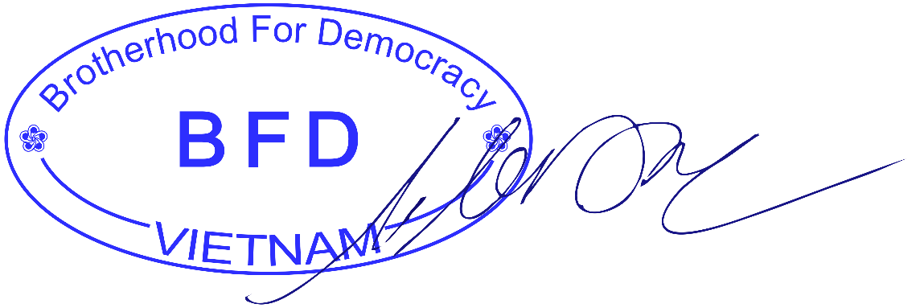
Address: Römerstr 7, Hanau 63450, Germany
Contact phone: +49 179-413-7618; Email: bfdvn2018@gmail.com
United Kingdom: Kemp House, 152-160 City Road, London, EC1V 2NX
Website: https://www.anhemdanchu.org ; Website: https://tinhottoancau.net/

Refer to Tables 1 and 2 of the Appendix.
Bach Van Hien, Phung Thanh Tuyen, Le Trung Thu. https://congan.com.vn/song-theo-phap-luat/bat3-doi-tuong-dung-mang-xa-hoi-chong-pha-nhanuoc_115355.html
Phap luat Online, Can Tho: 1 female Facebooker sentenced to 2 years in prison (April 22, 2021) https://plo.vn/phap-luat/can-tho-1-nu-facebooker-bi-phat-2-nam-tu-980329.html
VietnamNet, Investigate university lecturers who make one-sided statements about epidemic prevention (August 7, 2021) https://vietnamnet.vn/vn/thoi-su/dieu-tra-video-giang-vien-dai-hoc-phat-ngon-phien-dien-ve-congtacphong-dich-763804.html
This documentary is still on Youtube, please refer to 9:22 minutes at https://www.youtube.com/watch?v=BPrjtLJAxCc
Vietnam Human Rights Network, Report on Human Rights in Vietnam 2020-2021 (data updated to 31/05/2021)
RFA, Xuan Loc Prison: Political prisoners protest collectively because they are locked in a cell 24/7 (November 29, 2021), https://www.rfa.org/vietnamese/news/vietnamnews/political-prisoners-inxuanloc-prison-protest-collectively-11292021073601.html
RFA, Unusuals in the prison warden's case was arrested "for using corporal punishment" (December 17, 2021) https://www.rfa.org/vietnamese/in_depth/wrongdoing-indetainingwhistleblower-12172021102931.html
Tuoi tre Onlline. Checking the death of a suspect being detained in Chi Hoa. https://tuoitre.vn/kiemtra-thong-tin-mot-bi-can-dang-bi-giam-tai-chi-hoa-tu-vong20210116122819254.htm ¹⁰ Tuoi tre Online. Died by hanging at his home after working with the police. https://thanhnien.vn/thoi-su/chet-trong-tu-the-treo-co-tai-nha-rieng-sau-khi-lam-viec-voi-coquancong-an-1329651. html
Thanh nien, Lam Dong: A person died after being invited to police station https://thanhnien.vn/lamdong-mot-nguoi-tu-vong-sau-khi-cong-an-xa-moi-len-tru-so-lam-viecpost1115437.html ¹² https://tuoitre.vn/xet-xu-nhom-cuop-tuoi-vi-thanh-nien-o-vinh-long20211126183940259.htm
https://nld.com.vn/thoi-su/dieu-tra-vu-nguoi-dan-ong-chet-sau-khi-len-cong-an-xa-lamviec20211229183852513.htm
RFA. Rejecting the explanation of the Ministry of Public Security about the problem of 'suicide' in detention. https://www.rfa.org/vietnamese/in_depth/denouncing-ministry-of-public-securitysexplanation-to-the-un-on-death-in-custody-dt-03132019130320.html
The People's Army, Military Department of Gia Lai province announced the cause of death of soldier Nguyen Van Thien (December 1, 2021), https://www.qdnd.vn/phap-luat/tin-tuc/bo-chqstinhgia-lai-thong-bao-nguyen-nhan-tu-vong-cua-quan-nhan-nguyen-van- thien-679157
Tien phong, prosecuted the case of 'Deliberately causing injury' related to the death of a soldier in Gia Lai (January 5, 2022), https://tienphong.vn/khoi-to-vu-an-co-y-gay-thuong-tich-lien-quan-vuquannhan-tu-vong-o-gia-lai-post1407163.tpo
Report No. 783/BC-HDBCQG This 14/07/2021 on the summary of the election of deputies to the 15th National Assembly and People's Councils at all levels for the term 2021-2026.
Ninh Binh Newspaper, Appropriate punishment for the act of disseminating information against the State (October 28, 2021), https://baoninhbinh.org.vn/hinh-phat-thich-dang-cho-hanh-vi-tuyentruyenthong-tin/d20211028154112675.htm
RFA, Binh Thuan Police released Mr. Nguyen Van Son Trung after 5 days of detention to ask about "self-nomination" (April 14, 2021). https://www.rfa.org/vietnamese/news/vietnamnews/nguyenvanson-trung-released-after-five-day-detention-working-with-police-on-seflnomination04142021090400.html
Electronic portal of Phu Lam Ward, Ha Dong District, Hanoi, The ward’s Party Committee organized an assessment of the results of implementing Project 132 - DA/TG of the Propaganda Department of the District Party Committee in the first 6 months of the year and deploying tasks for the next 6 months of 2018, http://phulam.hadong.hanoi.gov.vn/dang-uy-phuong-chuc-danh-gia-ketquathuc-hien-noi-dung-de-132-datg-cua-ban-tuyen- omission of authority
General Statistics Office, Press Release of Results of the Sustainable Development Goals Survey on Vietnamese Children and Women 2020-2021 (December 8, 2021), https://www.gso.gov.vn/du-lieuvaso-lieu-thong-ke/2021/12/thong-cao-bao-chi-ket-qua-dieu-tra-cac-muc- tieu-phat-trien-ben-vungvetre-em-va-phu-nu-viet-nam-2020-2021/
VOV, More than 4,000 children have been abused in the past 2 years (October 28, 2021), https://vov.vn/xa-hoi/tin-24h/hon-4000-tre-em-bi-xam-hai-trong-2-nam-qua-900908.vov
Tuoi tre Online, Trial of a group of underage robbers in Vinh Long (November 26, 2021), https://tuoitre.vn/xet-xu-nhom-cuop-tuoi-vi-thanh-nien-o-vinh-long-20211126183940259.htm ²⁴ Phap luat Online, Prolonging the case of blocking students from stealing money in Vinh Long (November 27, 2021), https://plo.vn/phap-luat/nghi-an-keo-dai-vu-an-chan-duong-hoc-sinh-cuop-tieno-vinh-long1030396.html
Tuoi tre Online, Sentencing a group of teenagers robbing property in Vinh Long (December 2, 2021): https://tuoitre.vn/tuyen-an-nhom-thanh-thieu-nien-cuop-tai-san-o-vinhlong20211202092631431.htm
GSO, Press release on Labour situation in the fourth quarter of 2021 and the development indicator of Vietnamese 2016 - 2020, https://www.gso.gov.vn/du-lieu-va-so-lieu-thong-ke/2022/01/thongcaobao-chi-tinh-hinh-lao-dong-viec-lam- qui-iv-nam-2021-va-chi-so-phat-trien-con-nguoi-vietnam2016-2020/
VOV, People in HCM city frustrated because of not receiving supporting money https://vov.vn/xahoi/nhieu-nguoi-dan-tphcm-buc-xuc-vi-khong-nhan-duoc-tien-ho-tro-882245.vov ²⁶ Updated data on the website of the Ministry of Health's portal on the Covid-19 pandemic on January 10, 2022: https://covid19.gov.vn
VTV.vn. More than 8,000 workers went on strike and gathered to demand higher wages. https://vtv.vn/xa-hoi/hon-8000-cong-nhan-dinh-cong-tu-tap-doi-tang-luong-20210226121657572.htm
Vietnamese RFA, https://www.youtube.com/watch?v=-aeEn4tU934
Tuoi trẻ Online, https://tuoitre.vn/hang-ngan-cong-nhan-pouchen-ngung-viec-do-tien-thuongtetgiam-20220107153613095.htm
Online Police Department, Hide in the shadow of "workers' representative organizations" to oppose the Party and State (October 4, 2021): https://cand.com.vn/Chong-dien-bien-hoa-binh/nup-bongtochuc-dai-dien-nguoi-lao-dong-de-chong-pha-dang-nha-nuoc- i630256/
Speech by Mr. Bernd Lange, Chairman of the European Parliament's International Trade Committee INTA at the Seminar "Update EVFTA (I): Progress towards ratification and implementation of EVFTA and key trade issues trade and sustainable development” held in Hanoi on November 1, 2019. https://www.rfa.org/vietnamese/news/comment/ReadersOpinions/how-civil-society-caninfluenceevfta-implementation-11062019101739.html
Ministry of Industry and Trade, Notice of receiving information of interest as a member of Vietnam's domestic advisory group (DAG) to implement the EVFTA Agreement (October 5, 2020) https://moit.gov.vn/tin-tuc/thi-truong-nuoc-ngoai/thong-bao-tiep-nhan-thong-tin-quan-tam-lamthanhvien-nhom-t.html
Ministry of Industry and Trade, Additional members of Vietnam's Domestic Advisory Group (DAG) in the EVFTA Agreement: https://moit.gov.vn/tin-tuc/thong-bao/bo-sung-thanh-vien-cua-nhom-tuvantrong-nuoc-dag-viet-nam-trong-hiep-dinh- evfta.html
VnEconomy, "EVFTA must bring benefits to people, not only economic giants" (November 1, 2019) https://vneconomy.vn/evfta-phai-dem-lai-loi-ich-cho-nguoi-dan-chu-khong-chi-cac-dai-gia-tinh-te.htm
Thanhnien Online, Prime Minister: 'The social isolation only stops at the level of advocacy and persuasion', (March 31, 2020,) at https://thanhnien.vn/thoi-su/thu-tuong-cach-ly-toan-xa-hoi-moidungo-muc-van-dong-thuyet-phuc-1204092.html
Government Newspaper, Prime Minister: The latest solutions are 'pre emergency' (March 31, 2020) http://baochinhphu.vn/Tin-noi-bat/Thu-tuong-Cac-giai-phap-moi-nhat-mang-tinh-tienkhancap/391495.vgp
Online newspaper of the Communist Party of Vietnam, "Social isolation" is not a roadblock, a car ban, a local blockade, (April 3, 2020). http://dangcongsan.vn/ban-doc/luat-su-cua-ban/cach- lytoanxa-hoi-khong-phai-la-rao-duong-cam-xe-phong-toa-dia- phuong-551903.html
City Police Newspaper. Ho Chi Minh City, Ho Chi Minh City: Fined more than 12,000 cases of violating Directive 16 with an amount of 3.3 billion VND (July 13, 2021),https://congan.com.vn/doisong/tphcm-phat-hon-12000-vu-vi-pham-chi-thi-16-voi-so-tien-33-tydong_116102.html
Tuoi Tre Online, Hanoi: An average of 1,000 cases of anti-epidemic violations will be sanctioned (August 26, 2021). https://tuoitre.vn/ha-noi-xu-phat-trung-binh-moi-ngay-1000-truong-hop-viphamchong-dich-20210826060517611.htm
NLD, Go Vap District People's Committee explained the document with the content of sanctioning norms of ward 6 (July 13, 2021), https://nld.com.vn/thoi-su/ubnd-quan-go-vap-giai-thich-ve-vanbanco-noi-dung-chi-tieu-xu-phat-vi-pham- chi-thi-16-cua-phuong-6-20210713160954384.htm ⁴⁴ VietnamNet, Consider handling drug delivery people who do not follow the correct route, leave when being sanctioned (August 19, 2021), https://vietnamnet.vn/vn/thoi-su/an-toan-Giao-thong/xemxet-xuly-nguoi-Giao-thuoc-khong-dung-lo-trinh-bo-di-khi- Bi-xu-phat-767305.html
Resolution 21/NQ-CP dated February 26, 2021 on purchasing and using vaccines against Covid-19.
Tuoi tre Online, Prosecuting the case of 70 people coming to the Commune People's Committee to ask for money to support Covid-19 (October 28, 2021), https://tuoitre.vn/khoi-to-vu-70-nguoikeonhau-den-ubnd-xa-doi-tien-ho-tro-covid-19-202110281315242.htm
VOV, 2 subjects posted false news, inciting people to voluntarily leave their hometown (October 2, 2021), https://vov.vn/phap-luat/2-doi-tuong-dang-tin-sai-su-that-kich-dong-nguoi-dan-tu-y-bo-veque895191.vov
Quote from Prime Minister Pham Minh Chinh’s speech at a meeting with Vietnamese people in the UK on October 31, 2021.

